**UNIVERSITY OF MADRAS**

**GUINDY CAMPUS, CHENNAI-600 025**



**DEPARTMENT OF COMPUTER SCIENCE**

**INTERNSHIP PROJECT REPORT**

**TOPIC**

**E-COMMERCE WEBSITE**

**(KAVIGAI INTERSHIP)**

**Submitted by**

**ROHITT KUMAR - 36823112**

**MSC CS II**

# 

Under the Guidance of

**Dr. B. LAVANYA., MCA., PhD.**

# UNIVERSITY OF MADRAS

**DEPARTMENT OF COMPUTER SCIENCE**

## **GUINDY CAMPUS, CHENNAI-600 025**



**BONAFIDE CERTIFICATE**

This is to certify that the Major Project work entitled “**E-COMMERCE WEBSITE” (KAVIGAI INTERSHIP)** submitted to the University of Madras, Guindy by **ROHITT KUMAR D** (**36823112**) in partial fulfilment of the requirements for the award of the degree., is a BonafIde record of the project work carried out by me during the academic period **MAY 2024 – JUNE 2024.**

**PROJECT GUIDE**  **HEAD OF THE DEPARTMENT**  Dr. B. Lavanya MCA., PhD. Dr. S. Gopinathan .,M.sc., PhD.

Submitted for the project Examination held on _____________ at the Department of Computer Science, University of Madras, Guindy, Chennai – 600 025.

Internal Examiner External Examiner

DECLARATION

I hereby declare that the Major Project entitled **"E-COMMERCE WEBSITE” (KAVIGAI SUMMER INTERNSHIP)**, is submitted by me for the award of the degree of MSC in Computer Science from University of Madras is a record of project work done by me during the period MAY 2024 - JUNE2024 and the Major Project has not formed the basis for the award of any degree or other similar titles.

PLACE: Chennai. SIGNATURE

DATE: (ROHITT KUMAR D)



**TABLE OF CONTENT**

|  |  |  |
| --- | --- | --- |
| S No | TOPIC | PAGE NO |
| 01 | ACKNOWLDGEMENT | 1 |
| 02 | ABSTRACT | 2 |
| 03 | ABOUT ORGANIZATION | 3 |
| 04 | SYSTEM OVERVIEW | 4 |
| 05 | GOALS | 5 |
| 06 | WORKFLOW | 6 |
| 07 | SYSTEM DESIGN | 14 |
| 08  09  10  11  12 | MODULE SPECIFICATION  MY CONTRIBUTION  OUTPUTS  CONCLUSION  REFERENCES  REFERENCES | 15  16  17  35  36 |

## **ACKNOWLEDGEMENT**

I am deeply grateful to ***Dr. S. Gopinathan***, the Head of the Computer Science Department at the University of Madras, for his invaluable guidance and encouragement throughout my journey. I also extend my heartfelt thanks to ***Mr. Shiva Thirumazhusai***, the CEO of Naso Technologies Pvt. Ltd., for his guidance and support whenever needed during this course.

I am especially thankful to ***Mrs. Suganya Munuswamy***, the Lead Software Engineer at Naso Technologies Pvt. Ltd., for her assistance in choosing the department that aligned with my interests and for her continuous guidance during the internship, which helped me enhance my skills significantly.

Lastly, I want to express my gratitude to my parents, friends, and all those who supported me during this internship and helped me successfully complete it. Their unwavering support has been instrumental in my journey.

**Thanking You**

**ROHITT KUMAR D**

**(36823112)**

**ABSTRACT**

This project delivers a comprehensive and integrated solution for e-commerce operations, ensuring seamless collaboration between users, sellers, and administrators. It balances multiple functionalities, including user authentication, product management, payment processing, and analytics, with equal focus on every module.

Built with modern technologies like React, Redux, Node.js, and MySQL, the system is designed to be scalable, secure, and user-friendly. Middleware components streamline validation and error handling, while responsive design enhances accessibility.

This versatile platform is optimized for efficient operation across all its modules, providing a robust foundation for managing complex workflows in e-commerce environments.

**ABOUT ORGANIZATION**

Naso Technologies is an experienced technology and business consulting services firm with focus on solutions in the areas of Strategy, Process and Technology Services through Project Delivery Services and Staff Augmentation Services. Experienced in Mobile, Cloud, Artificial Intelligence, Web, and other scalable technologies.

Having highly experienced technology professionals, with hands on experience in creating, architecting, deploying a large number of software applications for legacy platforms, internet platforms and mobile platforms. Their software lifecycle includes business requirements analysis, designing solutions, deployment and configuration, project management, consulting, software development, technology support, data and web analytics.

One of their key strengths is to make applications that are deployed in 24 x forever highly scalable environment supporting multi-millions of simultaneous customers. Experience in managing global resources (software engineers, architects, QA, etc.).

**SYSTEM OVERVIEW**

The e-commerce platform integrates a variety of frontend, backend, and database technologies to deliver a seamless and scalable system. The user interface is powered by React and Tailwind CSS, ensuring responsiveness and interactivity. Redux is employed for managing application state consistently, while Node.js and Express.js handle server-side logic and API endpoint development. MySQL serves as the primary database, providing efficient and structured data storage.

Payment operations are securely managed through Razorpay integration. Middleware components optimize the system by handling authentication, error management, and validation.

The modular architecture ensures independent and flexible management of users, sellers, products, and orders. By leveraging cutting-edge technologies and best practices, this system addresses the challenges of managing an e-commerce platform efficiently and effectively.

**ROLES & RESPONSIBILITIES**

1. **Frontend Developer**: Responsible for creating and maintaining the user interface, ensuring responsiveness and usability through React and Tailwind CSS.
2. **Backend Developer**: Tasked with developing and maintaining server-side logic, API endpoints, and integration with the database using Node.js and Express.js.
3. **Database Administrator**: Designs, implements, and optimizes the MySQL database schema, ensuring data integrity and query efficiency.
4. **UI/UX Designer**: Develops wireframes, mockups, and prototypes using Figma, focusing on user-centric design principles.
5. **DevOps Engineer**: Manages deployment, version control, CI/CD pipelines, and ensures seamless integration across development environments.
6. **API Tester**: Uses tools like Postman to rigorously test API endpoints for functionality, performance, and security.

**SYSTEM STUDY**

**Problem Statement**

E-commerce platforms face significant challenges in managing administrative operations due to fragmented systems and manual workflows, leading to inefficiencies, errors, and operational bottlenecks. An integrated and scalable solution is required to streamline these processes.

**Primary Reason**

The rapid growth of e-commerce platforms increases the complexity of managing user data, seller applications, product listings, and payment transactions. Without a robust and integrated system, these operations become prone to inefficiencies and errors, affecting overall business performance.

**Existing Approach**

Many existing e-commerce platforms rely on separate tools and systems for managing users, products, and payments. These disconnected systems often lack scalability, advanced error handling, and seamless integration capabilities.

**Limitations of Existing Approach**

* Lack of robust error handling mechanisms.
* Inability to scale effectively with growing business demands.
* Inefficient integration with third-party payment gateways.
* Limited flexibility in managing modular components.

**Proposed Solution**

This project proposes a comprehensive API system that integrates frontend, backend, and database technologies to provide a seamless and efficient solution for managing e-commerce operations. The system emphasizes scalability, security, and user-centric design.

**GOALS**

The primary goals of the project are:

1. Ensure secure and scalable e-commerce operations.
2. Simplify and automate administrative workflows.
3. Integrate a secure payment gateway for streamlined transactions.
4. Enable modular management of platform components such as users, sellers, and products.
5. Enhance user experience through a responsive and intuitive interface.
6. Provide comprehensive analytics for actionable business insights.

**Scope**

The project targets the administrative requirements of e-commerce platforms, focusing on user, seller, product, and payment management. It ensures scalability, robust error handling, and efficient operation to cater to the dynamic needs of the industry.

**SYSTEM SPECIFICATION**

**3.1 Software Specification:**

1. **Frontend Technologies**: React, Tailwind CSS, Redux.
2. **Backend Technologies**: Node.js, Express.js.
3. **Database**: MySQL.
4. **Prototyping and Design**: Figma.
5. **API Testing**: Postman.
6. **Version Control**: Git, GitHub.
7. **Middleware Tools**: Custom validation and authentication modules.

**3.2 Framework Specification**:

1. **Frontend Workflow**: React components are integrated with Redux for state management and styled using Tailwind CSS. The user interface ensures a responsive and intuitive experience.
2. **Backend Workflow**: Node.js and Express.js handle API endpoints and server-side logic, facilitating secure and efficient communication with the database.
3. **Database Workflow**: MySQL supports structured data storage, ensuring efficient CRUD operations through optimized queries and connection pooling.
4. **Payment Gateway**: Razorpay integration manages secure payment transactions, providing a seamless experience for users.

**WORKFLOW**

**Diagram**:

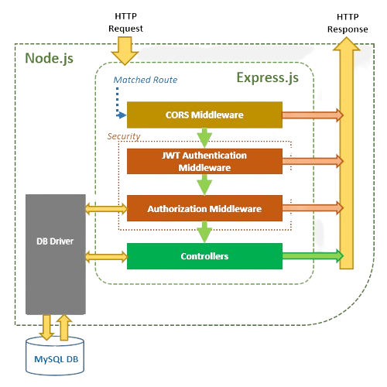

* The backend processes requests and queries the MySQL database for data retrieval or modification.
* Razorpay handles payment transactions, ensuring secure and validated operations.

**DETAILED WORKFLOW EXAMPLES**

**User Interaction Flow**

1. **Login Process**:
   * A user initiates login by entering credentials in the React-based interface.
   * The frontend sends an API request to the backend for authentication.
   * The backend validates the credentials using JWT and responds with a token.
   * The frontend stores the token securely and updates the application state via Redux.
2. **Product Purchase Flow**:
   * The user selects products and adds them to the cart.
   * An API request updates the cart in the MySQL database.
   * Upon checkout, the frontend communicates with Razorpay to initiate payment.
   * The backend verifies payment details and confirms the order.
3. **Account Management Flow**:
   * Users can update their profile details through the React frontend.
   * The frontend sends a PATCH request to the backend with the updated user information.
   * The backend validates the input, updates the database, and sends a confirmation response.
4. **Order Tracking**:
   * After placing an order, users can track its status on their dashboard.
   * The frontend periodically sends GET requests to the backend for the order's current status.
   * The backend retrieves the order status from the database and sends it back to the user.

**Seller Interaction Flow**

1. **Application to Sell**:
   * Sellers complete a form using the frontend.
   * The backend processes the application, validating data and updating the seller database.
   * Notifications are sent via email for application status.
2. **Product Management**:
   * Sellers can add new products through a form in their dashboard.
   * The frontend sends a POST request to the backend with product details.
   * The backend stores the product information in the database and sends a success response.
3. **Sales Tracking**:
   * Sellers view their sales data on their dashboard.
   * The frontend sends GET requests to the backend for sales statistics.
   * The backend aggregates data from the orders table and returns it to the seller.
4. **Product Updates**:
   * Sellers update product prices or stock levels using a form.
   * The frontend sends a PUT request to the backend with the updated details.
   * The backend validates the data, updates the database, and confirms the update.
5. **Order Management**:
   * Sellers process orders by updating their status (e.g., "Shipped").
   * The frontend sends a PUT request to the backend for the status change.
   * The backend updates the order record and notifies the customer.

**Admin Interaction Flow**

1. **Admin Login and Authentication**:
   * The admin logs into the platform using their credentials.
   * The frontend sends a POST request to the backend for authentication.
   * Upon successful validation via JWT, a token is issued, and the admin dashboard loads with personalized data.
2. **User Management**:
   * The admin accesses the user management module to view, edit, or delete user profiles.
   * A GET request fetches user data, which is displayed in a table format.
   * The admin can update user details via a PATCH request or deactivate accounts through a DELETE request.
3. **Seller Approval Workflow**:
   * Seller applications are reviewed by the admin.
   * A GET request fetches pending seller applications.
   * The admin approves or rejects applications using POST requests, with the decisions recorded in the database.
4. **Analytics and Insights**:
   * The admin dashboard displays aggregated metrics such as total revenue, active users, and completed orders.
   * These metrics are fetched through GET requests to the analytics API and displayed using visual components like charts and tables.
5. **Order Oversight**:
   * The admin monitors all orders across the platform.
   * GET requests retrieve order details, including statuses and timestamps.
   * Admins can manually update order statuses or resolve disputes by editing order records through PUT or PATCH requests.
6. **Product Management**:
   * Admins oversee the product catalog to ensure compliance with platform standards.
   * Using POST and DELETE requests, admins can add new products, remove inappropriate listings, or restore deleted products.
7. **System Health Monitoring**:
   * Admins receive notifications on server uptime and performance metrics via integrated monitoring tools.
   * Regular reports are generated, providing insights into API performance, error rates, and database query efficiency.

**TECHNICAL IMPLEMENTATION**

**1. Middleware**

* **Authentication Middleware**: Validates JWT tokens for secure access.
* **Error Handling Middleware**: Captures errors and formats consistent responses.
* **Validation Middleware**: Ensures request data adheres to required formats and schemas.

**2. API Endpoints**

**Seller Routes:**

1. **Seller Application**
   * POST /apply - Apply as a seller
2. **Seller Login**
   * POST /login - Seller login
3. **Seller Logout**
   * POST /logout - Seller logout
4. **Seller Dashboard**
   * GET /dashboard - Get seller details (dashboard)
5. **Seller Orders**
   * GET /getsellerorders - Get all seller orders
6. **Product Management**
   * POST /addproduct - Add product
   * DELETE /deleteproduct/:public_id - Delete product
   * DELETE /deleteproducts - Delete multiple products
   * PUT /restoreproduct/:product_id - Restore product
   * PUT /restoreproducts - Restore multiple products
   * PUT /updateproduct - Update product details
7. **Product Listings**
   * GET /getproducts - Get all products
   * GET /getproductdetails/:product_id - Get product details
8. **Order Management**
   * GET /orders - Get all orders by seller ID
   * GET /order/items/:order_id - Get all order items by seller ID and order ID
   * POST /order/item/updatestatus - Update order item status

**User Routes:**

1. **User Authentication**
   * POST /sendotp - Send OTP to user email
   * POST /loginsignup - Login or signup
   * POST /signupuser - Sign up new user
   * POST /logout - User logout
2. **User Information**
   * GET /dashboard - Get user details (dashboard)
   * POST /updateUser - Update user information
3. **Address Management**
   * POST /adddeliveryaddress - Add delivery address
   * POST /deletedeliveryaddress - Delete delivery address
   * POST /updateAddress - Update user address
4. **Order Management**
   * GET /orders - Get all orders
   * GET /order/items/:order_id - Get order items by order ID

**Product Routes:**

1. **Product Information**
   * GET /getallproducts - Get all products
   * GET /getdetails/:product_id - Get product details

**Payment Routes:**

1. **Payment Processing**
   * POST /checkout - Create order in Razorpay while checking out
   * POST /verification - Verify payment and insert record into orders table
2. **Razorpay API**
   * GET /getkey - Get Razorpay key

**Admin Routes:**

1. **Admin Authentication**
   * POST /login - Admin login
   * POST /logout - Admin logout
2. **Admin Dashboard**
   * GET /dashboard - Get admin details (dashboard)
3. **User Management**
   * GET /getallusers - Get all users
   * DELETE /deleteuser/:user_id - Delete user
4. **Seller Management**
   * GET /getallsellers - Get all sellers
   * GET /getsellerapplications - Get all pending seller applications
   * DELETE /deleteseller/:seller_id - Delete seller
   * POST /approveseller - Approve seller application
   * POST /rejectseller - Reject seller application
5. **Admin Management**
   * GET /getalladmins - Get all admins
   * POST /changeadminrole - Change admin role
   * POST /addadmin - Add new admin
   * DELETE /deleteadmin/:admin_id - Delete admin
6. **Admin Stats**
   * GET /stats - Get admin stats

**3. DATABASE SCHEMA:**

**Users Table**

* **Columns**: user_id, name, email, password_hash, role, created_at.
* **Relationships**: Links to orders and cart tables.

**Products Table**

* **Columns**: product_id, name, description, price, stock, category, is_deleted.
* **Relationships**: Links to order items and seller tables.

**Orders Table**

* **Columns**: order_id, user_id, total_price, status, created_at.
* **Relationships**: Links to users and order items tables.

**SYSTEM DESIGN**

**User Interface (UI):**

The user interface is developed with React and styled using Tailwind CSS, ensuring responsiveness, accessibility, and seamless user interaction.

**State Management:**

Redux is employed to manage application state, ensuring consistency and predictability across frontend components.

**Routing:**

React Router facilitates smooth navigation within the application, enabling users to access various modules seamlessly.

**Communication:**

AJAX requests are managed via Axios, providing efficient and asynchronous communication between the frontend and backend systems.

**Backend:**

* **Framework**: Node.js and Express.js serve as the backbone for API development.
* **Authentication**: Implements JWT-based authentication to secure user access.
* **Data Storage**: MySQL ensures efficient and structured data handling for large-scale operations.
* **Middleware**: Handles error management, authentication, and data validation to enhance system reliability.

**KEY COMPONENTS AND THEIR INTERACTION:**

**Frontend**: Built with React, ensuring a dynamic and responsive user experience.

**Backend**: API endpoints developed in Node.js and Express.js handle business logic and data processing**.**

**Database**: MySQL provides persistent and scalable data storage.

**Middleware**: Ensures secure and efficient request handling.

**Payment Gateway**: Razorpay integrates secure financial transactions seamlessly.

**MODULE SPECIFICATION**

1. **Authentication Module**: Securely manages login/logout functionality with role-based access control.
2. **User Management Module**: Supports CRUD operations for user profiles and associated data.
3. **Product Management Module**: Handles product creation, updates, deletions, and inventory tracking.
4. **Order Management Module**: Processes orders, updates statuses, and manages order details.
5. **Payment Processing Module**: Integrates Razorpay for secure and efficient transaction handling.
6. **Analytics Module**: Provides actionable insights through aggregated statistics on revenue, orders, and product performance.

**MY CONTRIBUTION**

### **Payment Gateway Integration and Checkout Page**

**Objective**:  
To implement a secure and user-friendly payment gateway and checkout system for seamless order completion.

**Key Features**:

1. **Checkout Page**:
   * **User Experience**:
     + Order summary with product details, quantity, and total cost.
     + Input fields for shipping information.
     + Payment method selection options.
   * **Functionalities**:
     + Real-time validation of inputs (e.g., contact number, ZIP code).
     + Dynamic total calculation based on cart contents.
     + Backend integration to save order details.
2. **Payment Gateway Integration**:
   * **Selected Gateway**: Razorpay for its robust API, multi-payment method support, and security features.
   * **Frontend Integration**:
     + Razorpay payment button and dynamic modal for transactions.
   * **Backend Integration**:
     + Razorpay APIs for secure order generation and transaction validation.
   * **Security**:
     + Tokenization, encryption, HTTPS, and secure API key handling.

**Implementation Details**:

* **Frontend (React)**: Integrated Razorpay checkout script for real-time payment status updates.
* **Backend (Node.js)**: Razorpay APIs used for secure order creation and validation.

This module ensures a smooth, reliable, and secure payment experience for users.

**OUTPUTS**

**1. Home Page**

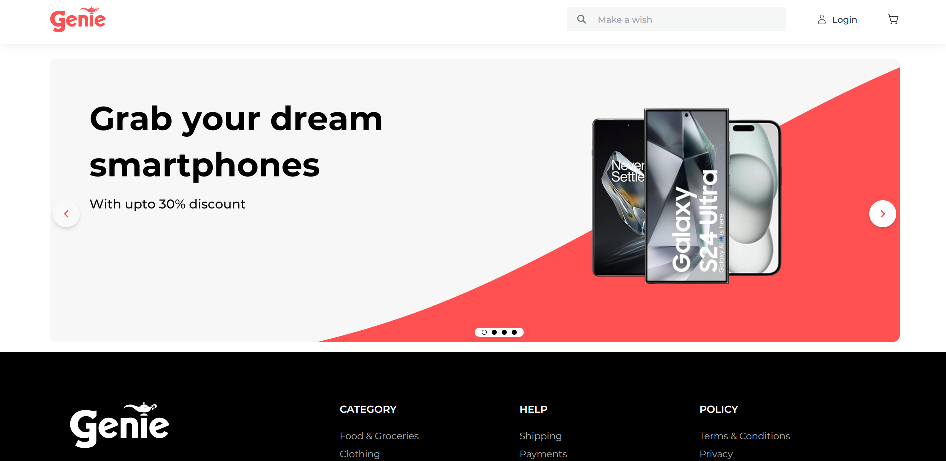

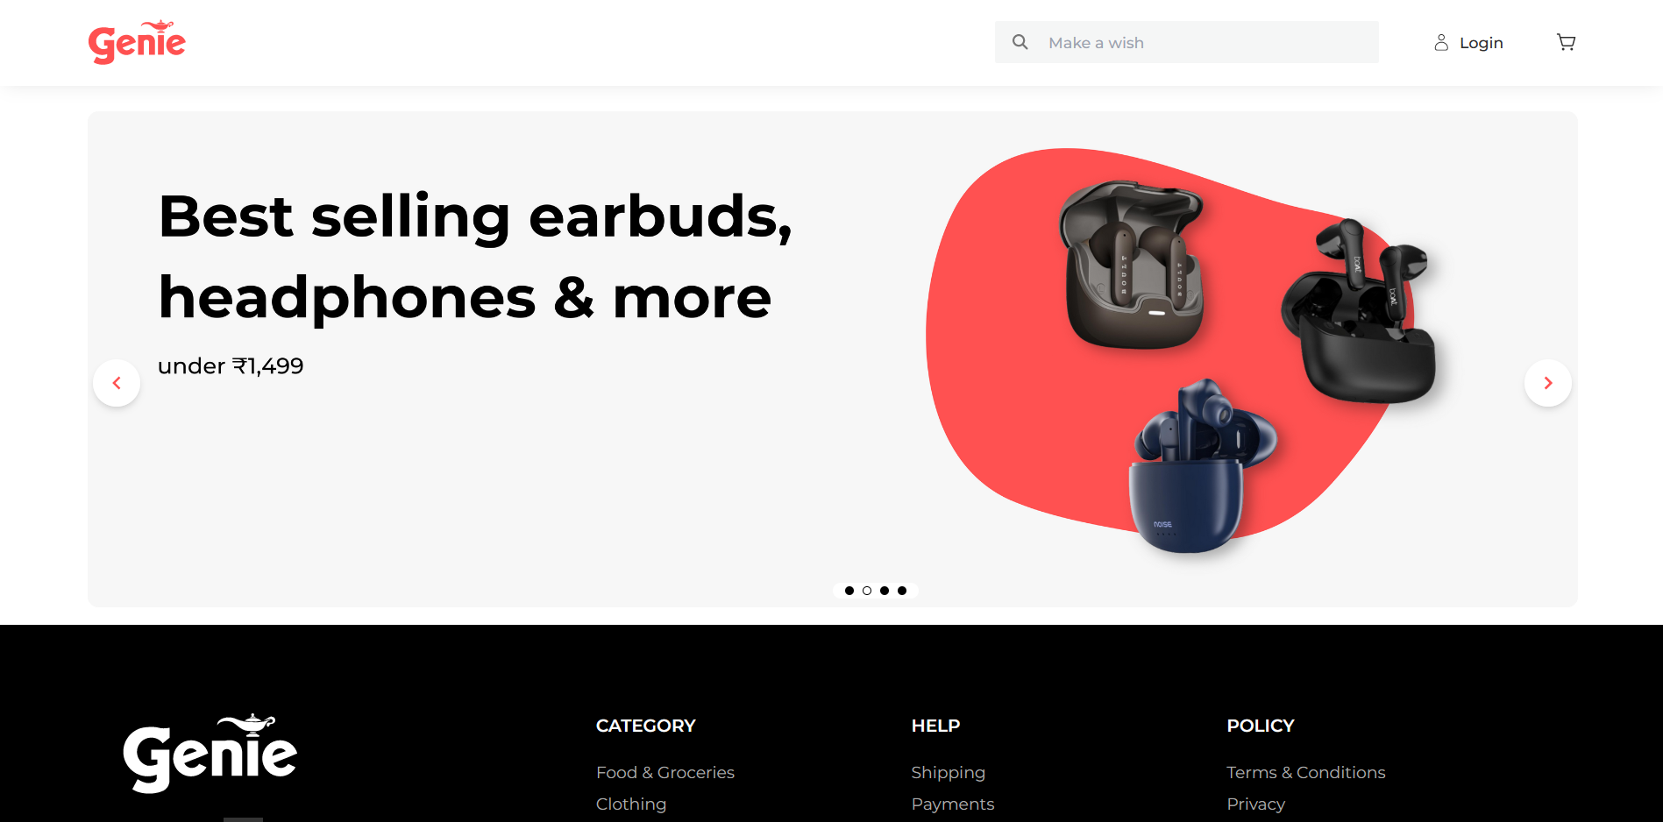

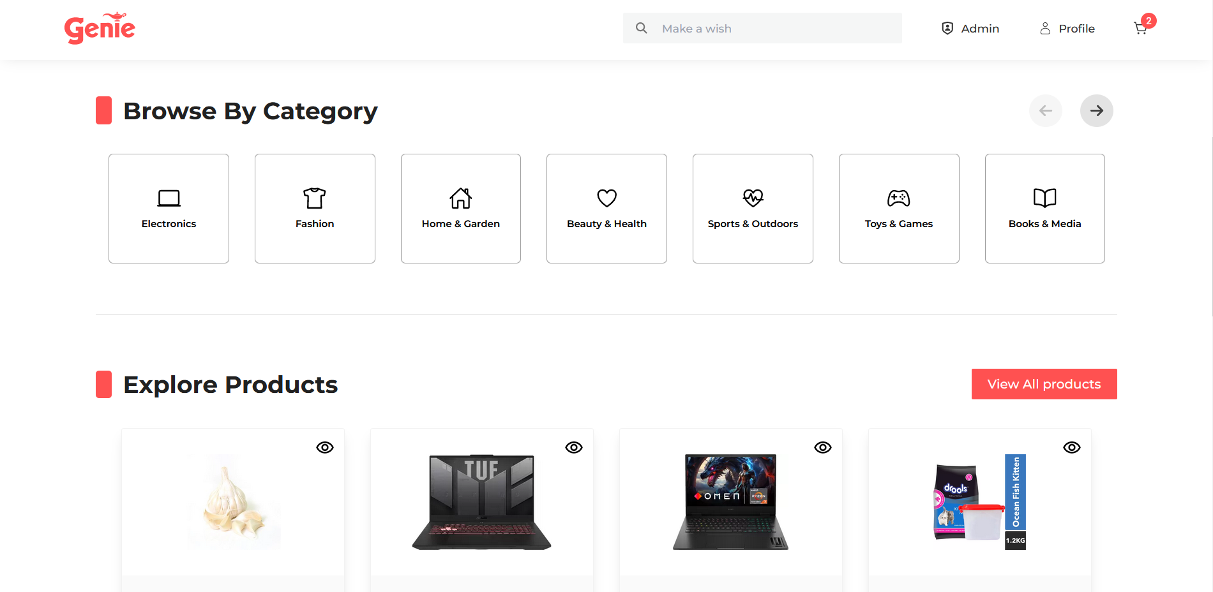

**2. Seller landing page**

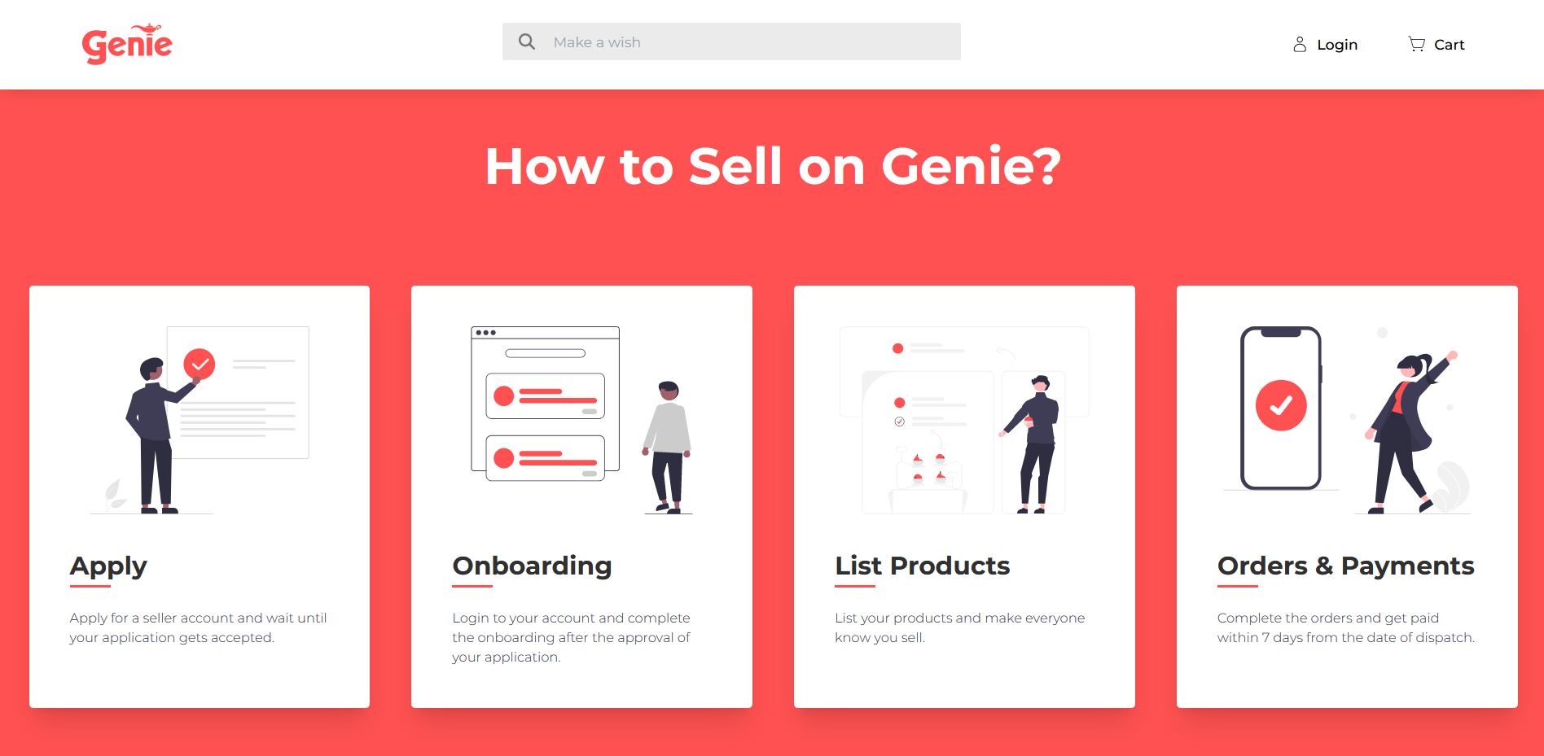

**Seller application**

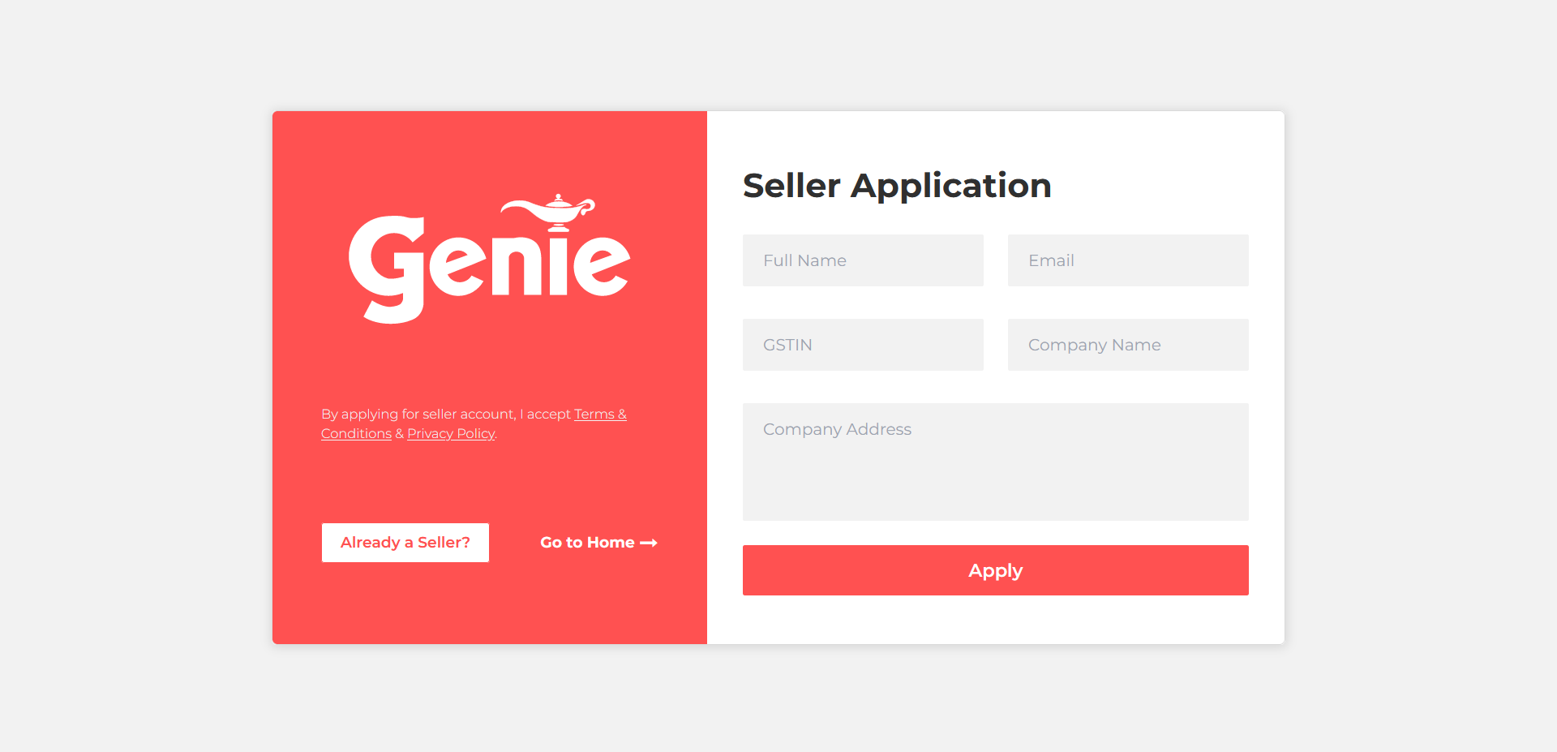

2.1. Already a seller

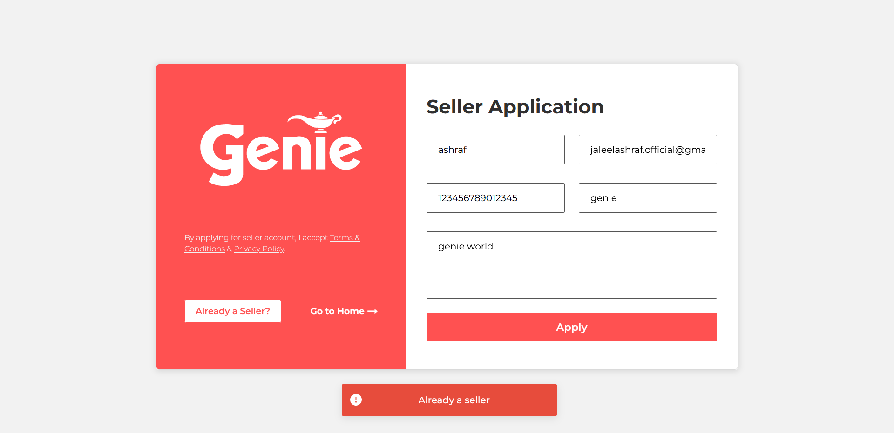

2.2. Already applied

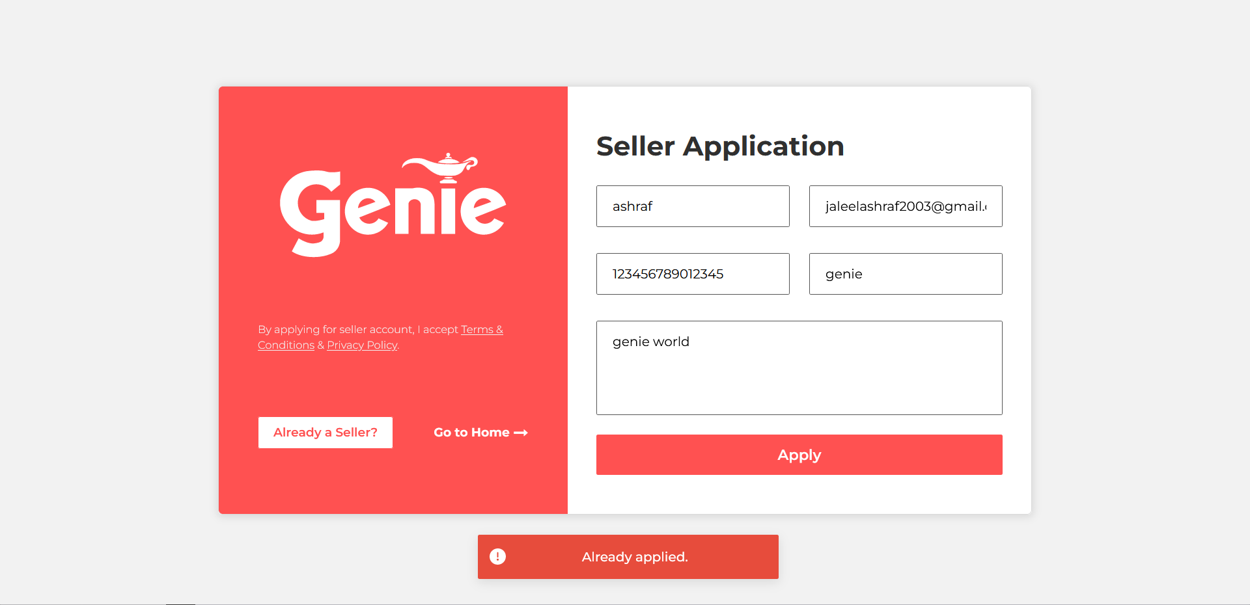

2.3. Application submitted successfully

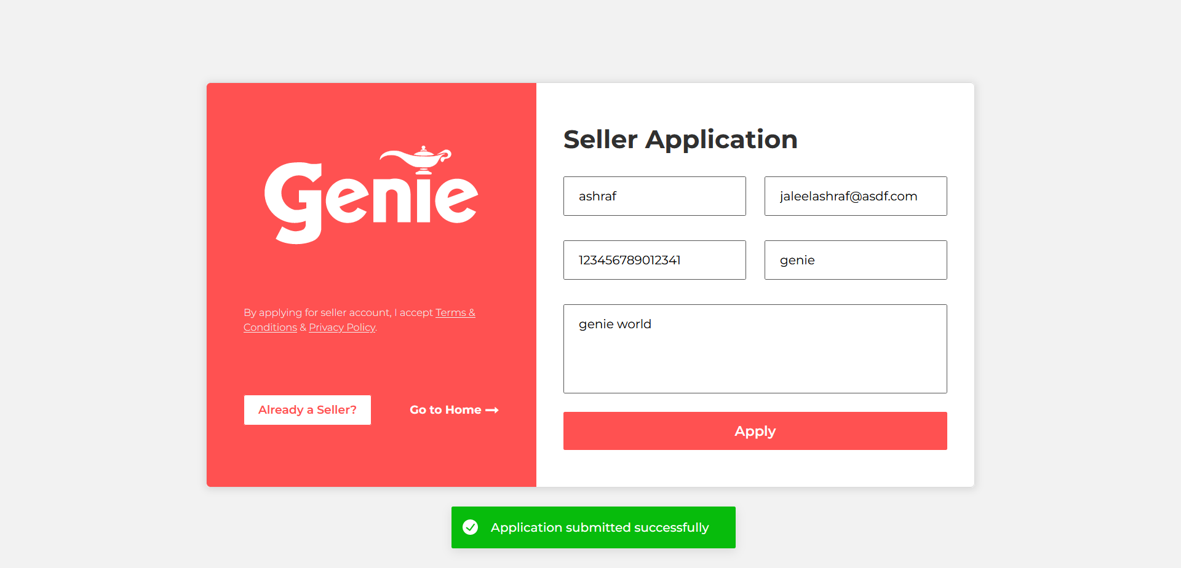

**3.1. Seller login**

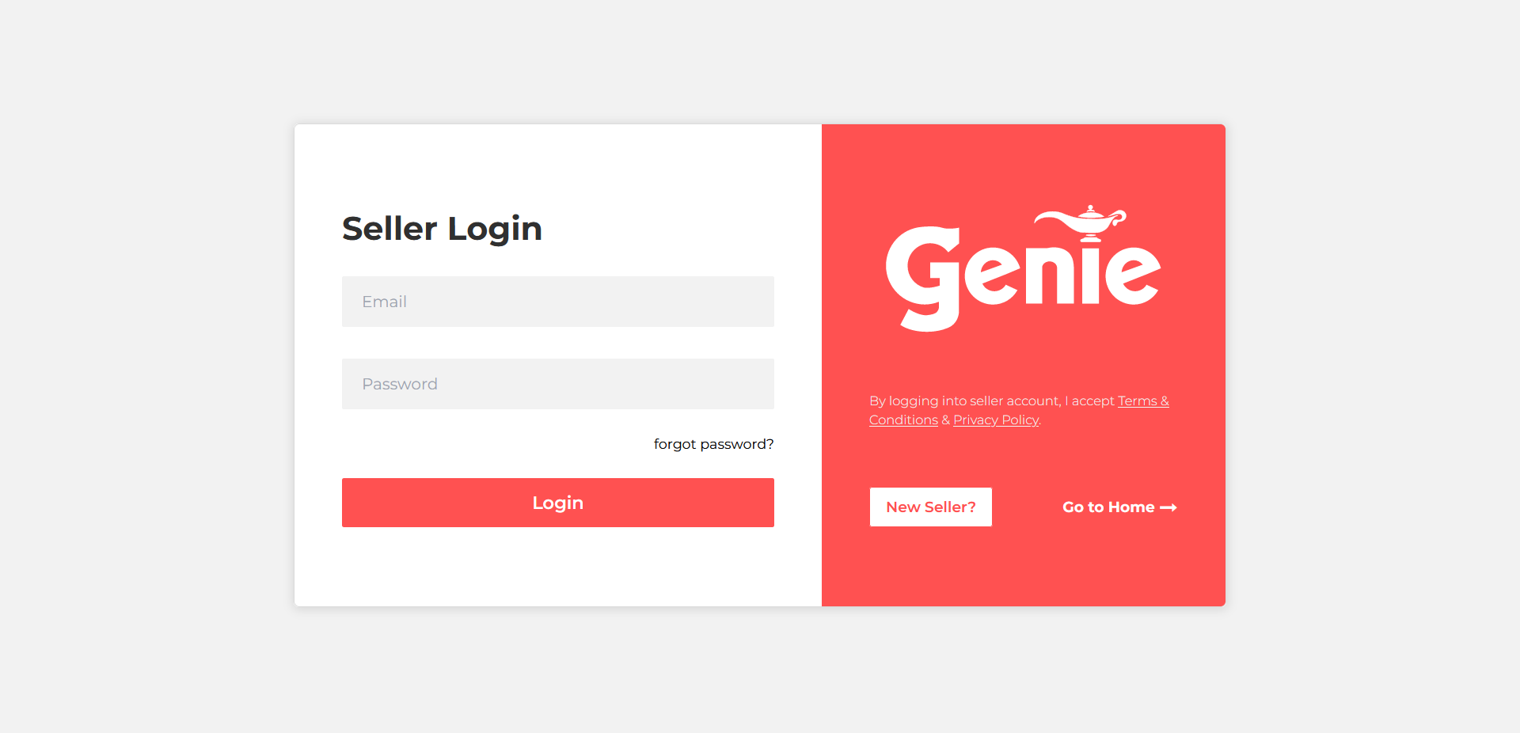

Invalid seller email or password

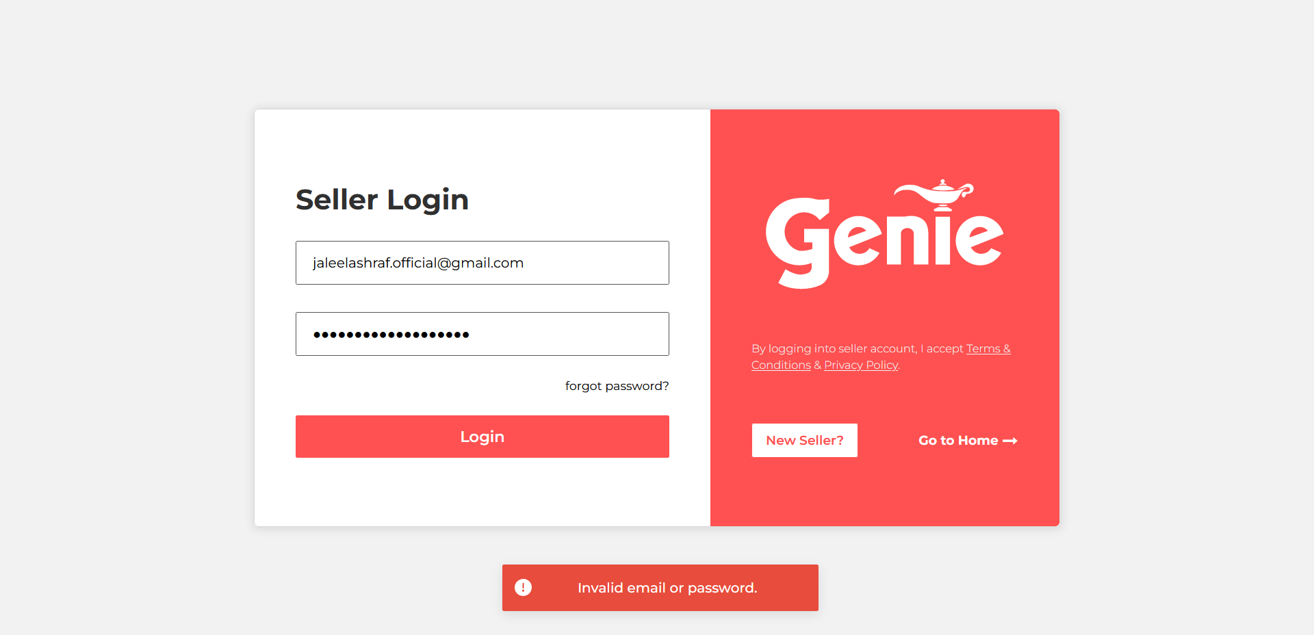

After logging in as seller

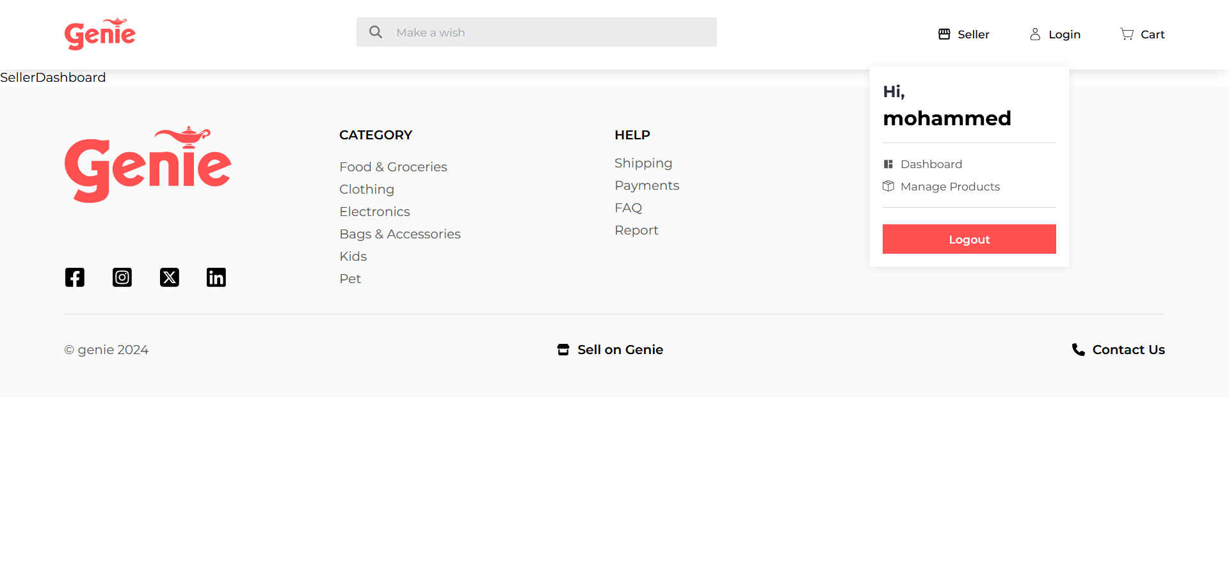

**Implementation of UI for listing, adding, deleting and updating products of seller module**

Products list

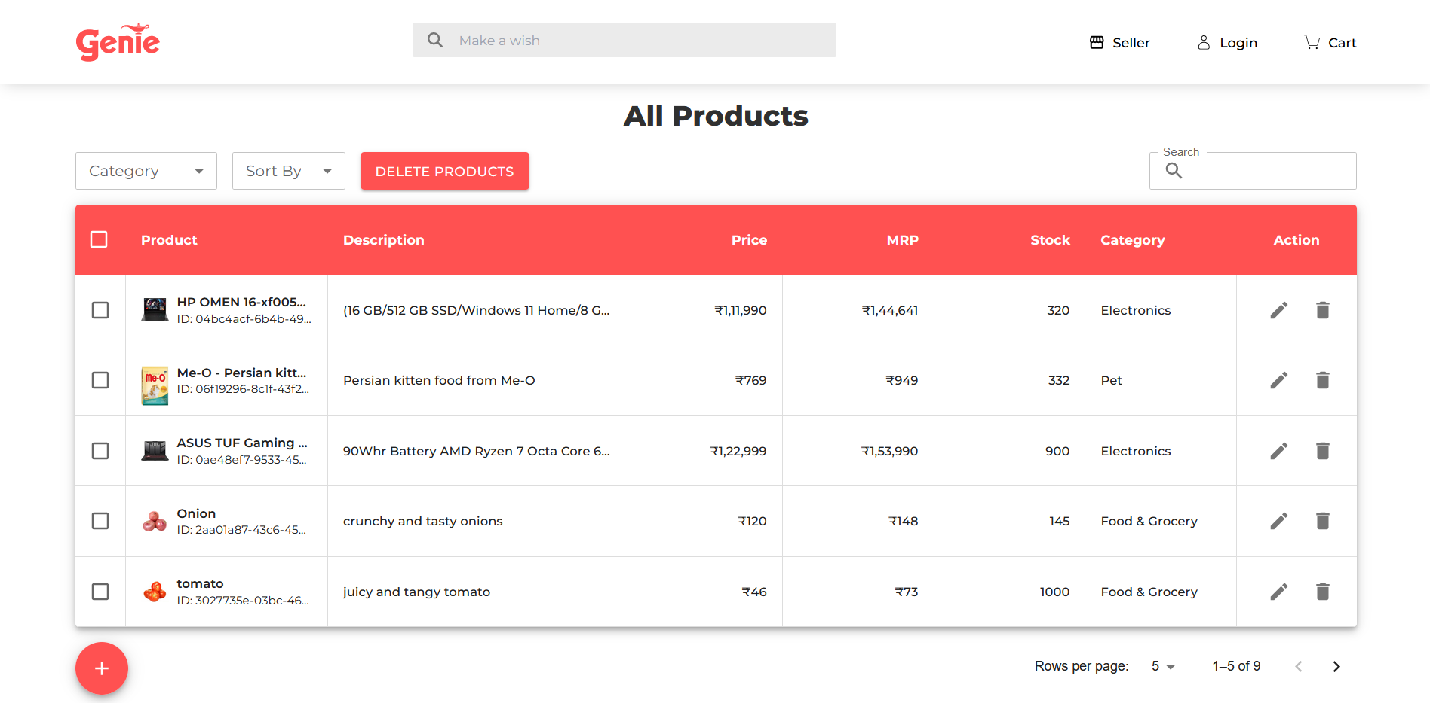

Add products

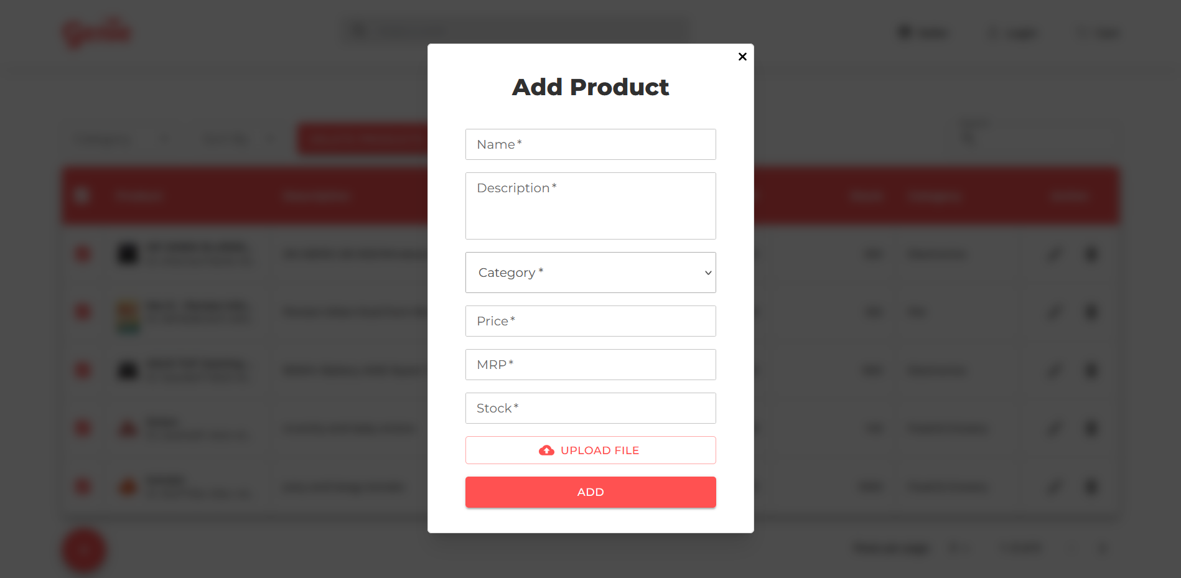

Delete products

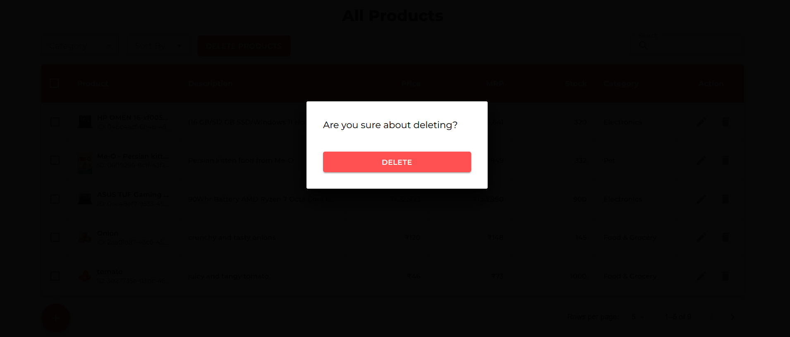

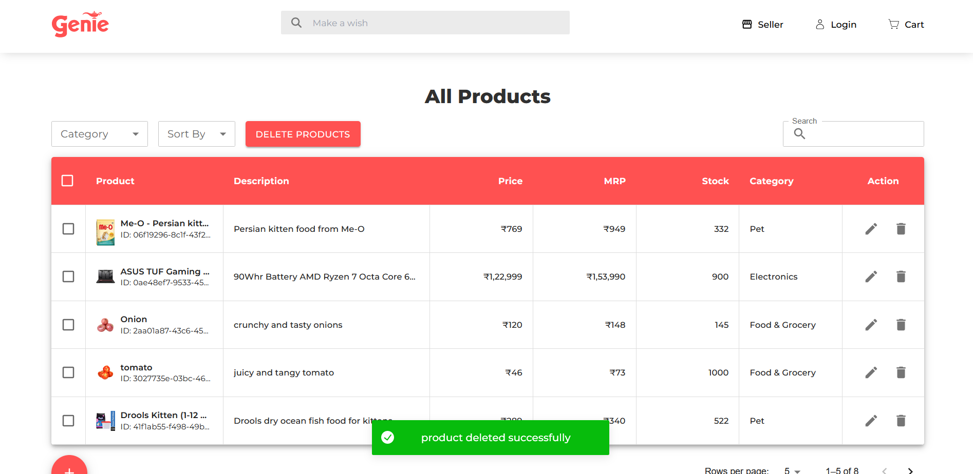

Update product

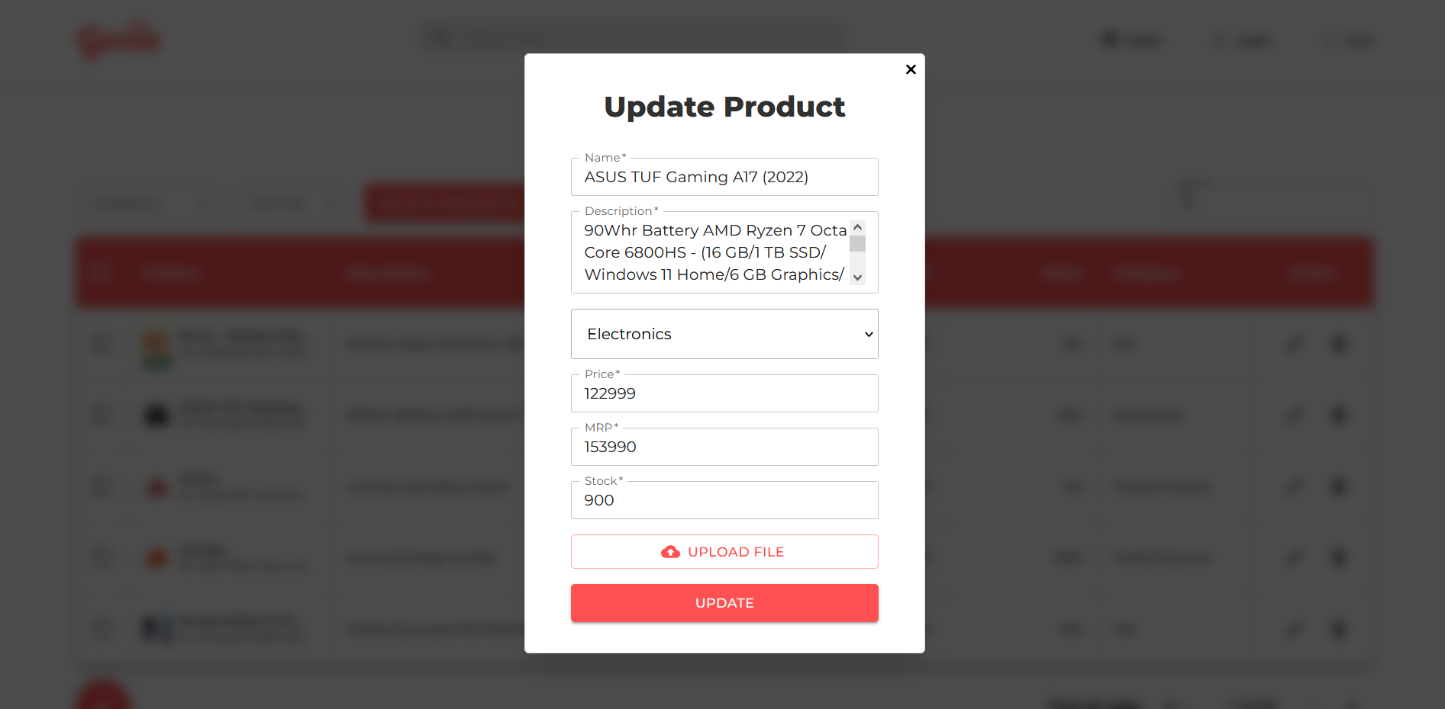

Categorize product

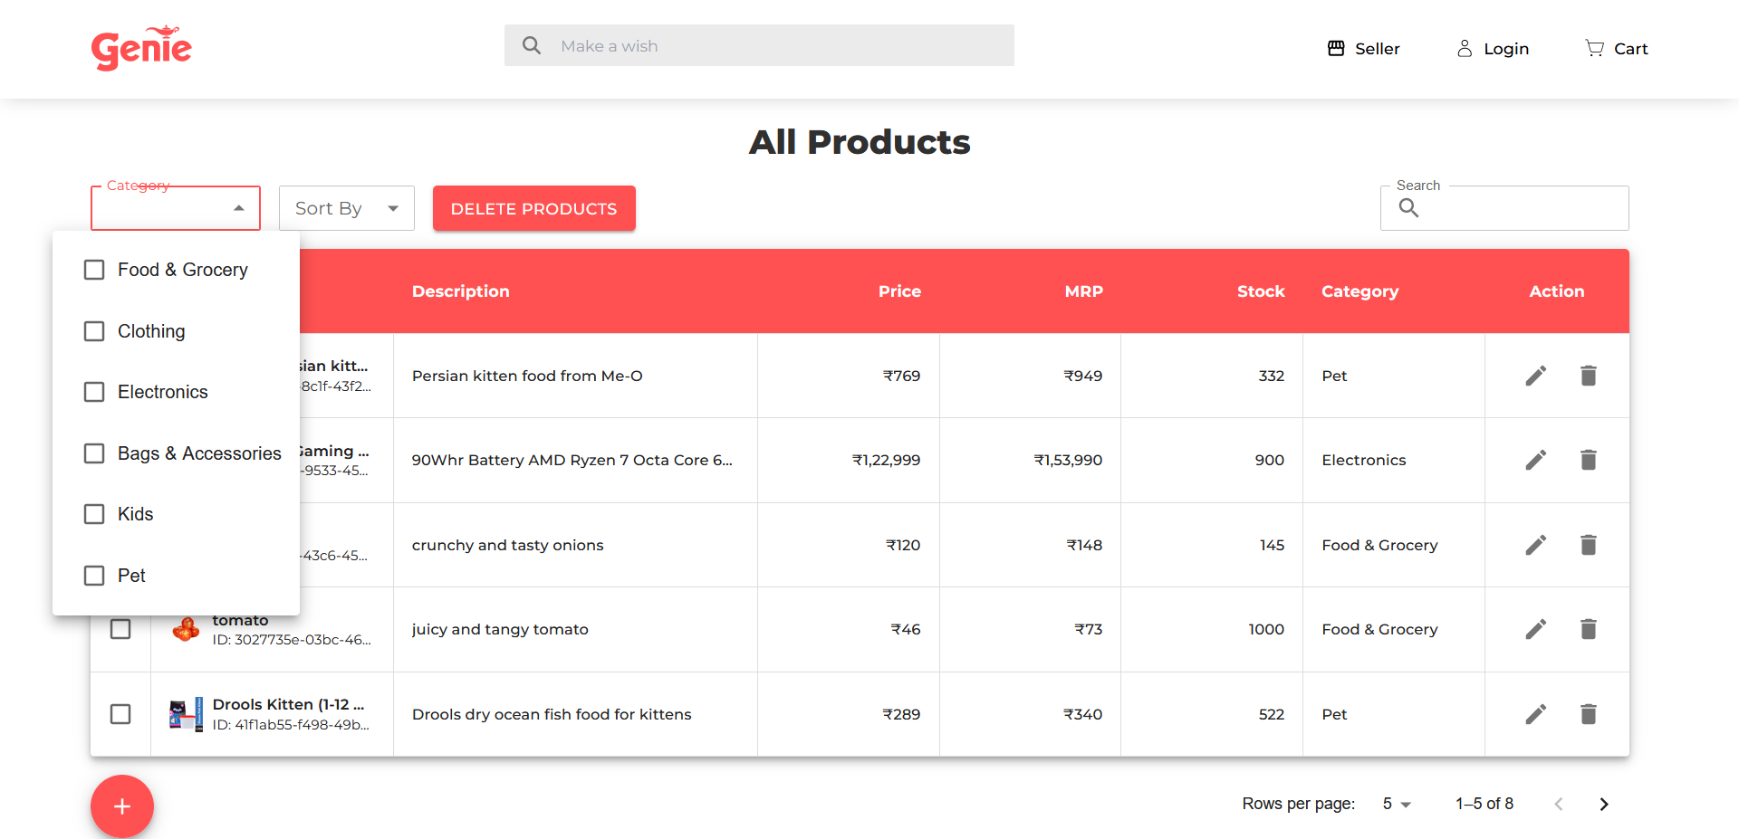

Category: Electronics

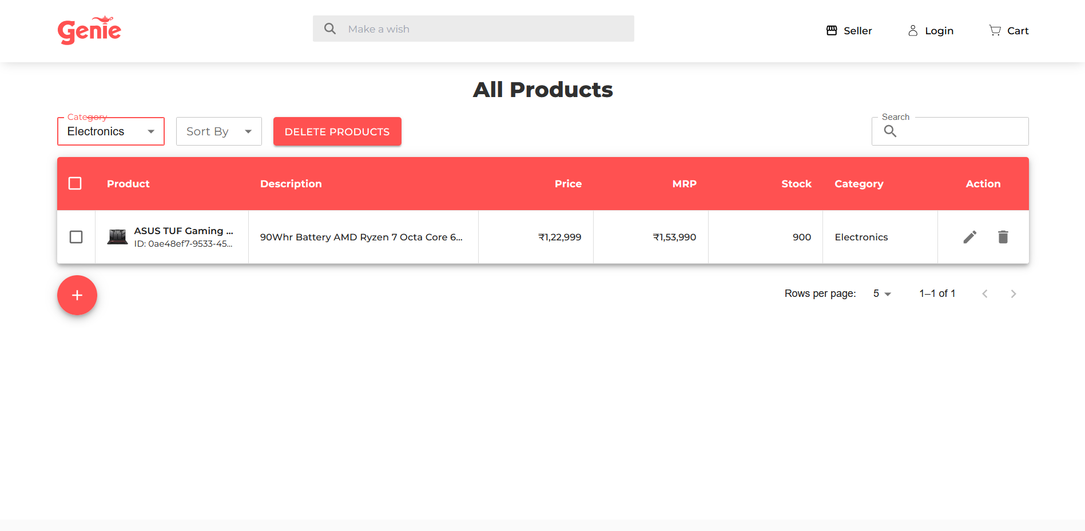

Categories: Electronics, food & grocery

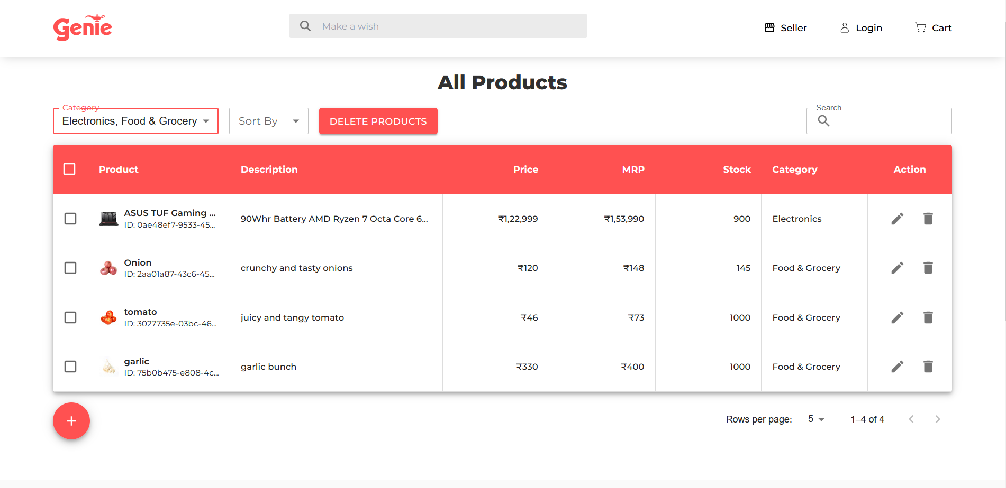

Search product

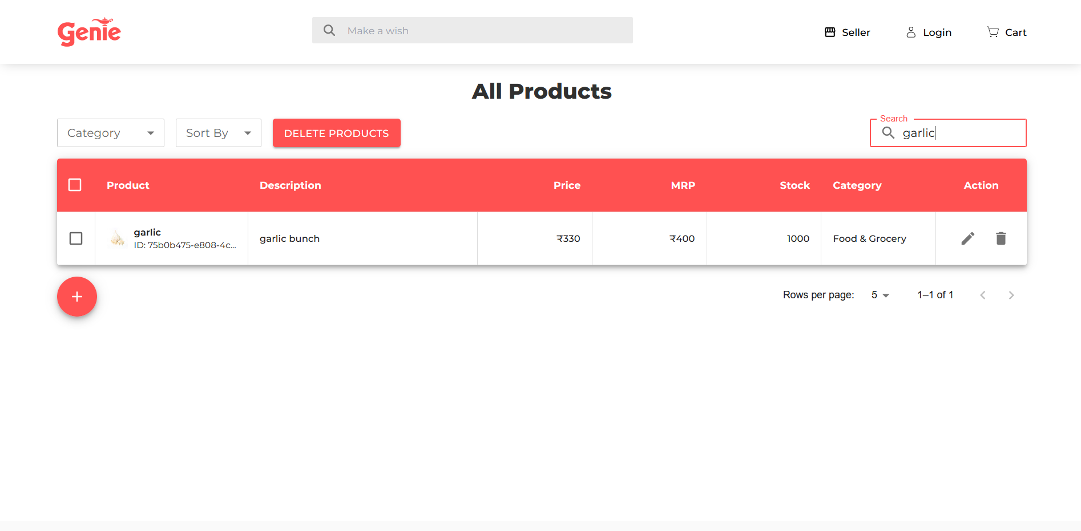

Sort products

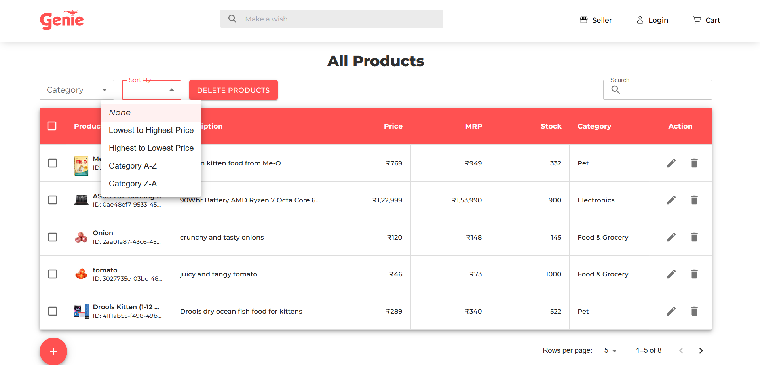

Sorting from lowest to highest price

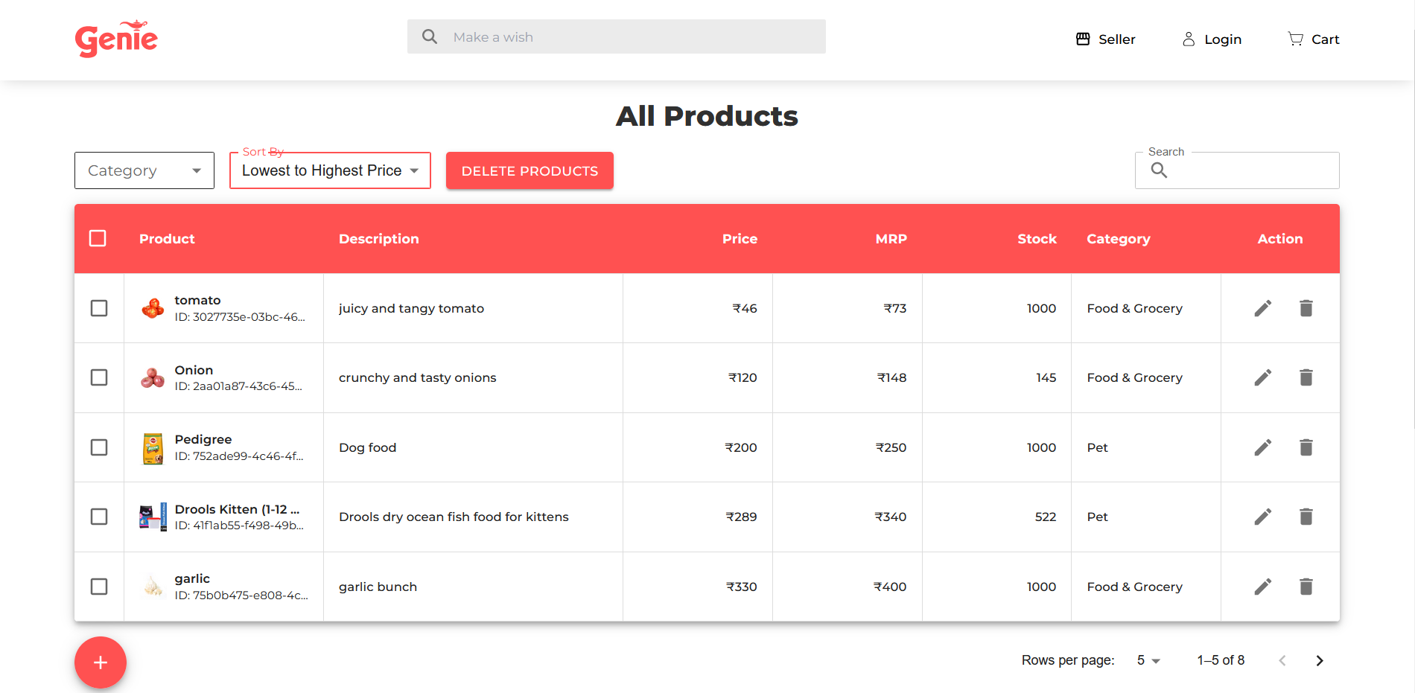

Selecting and deleting all products

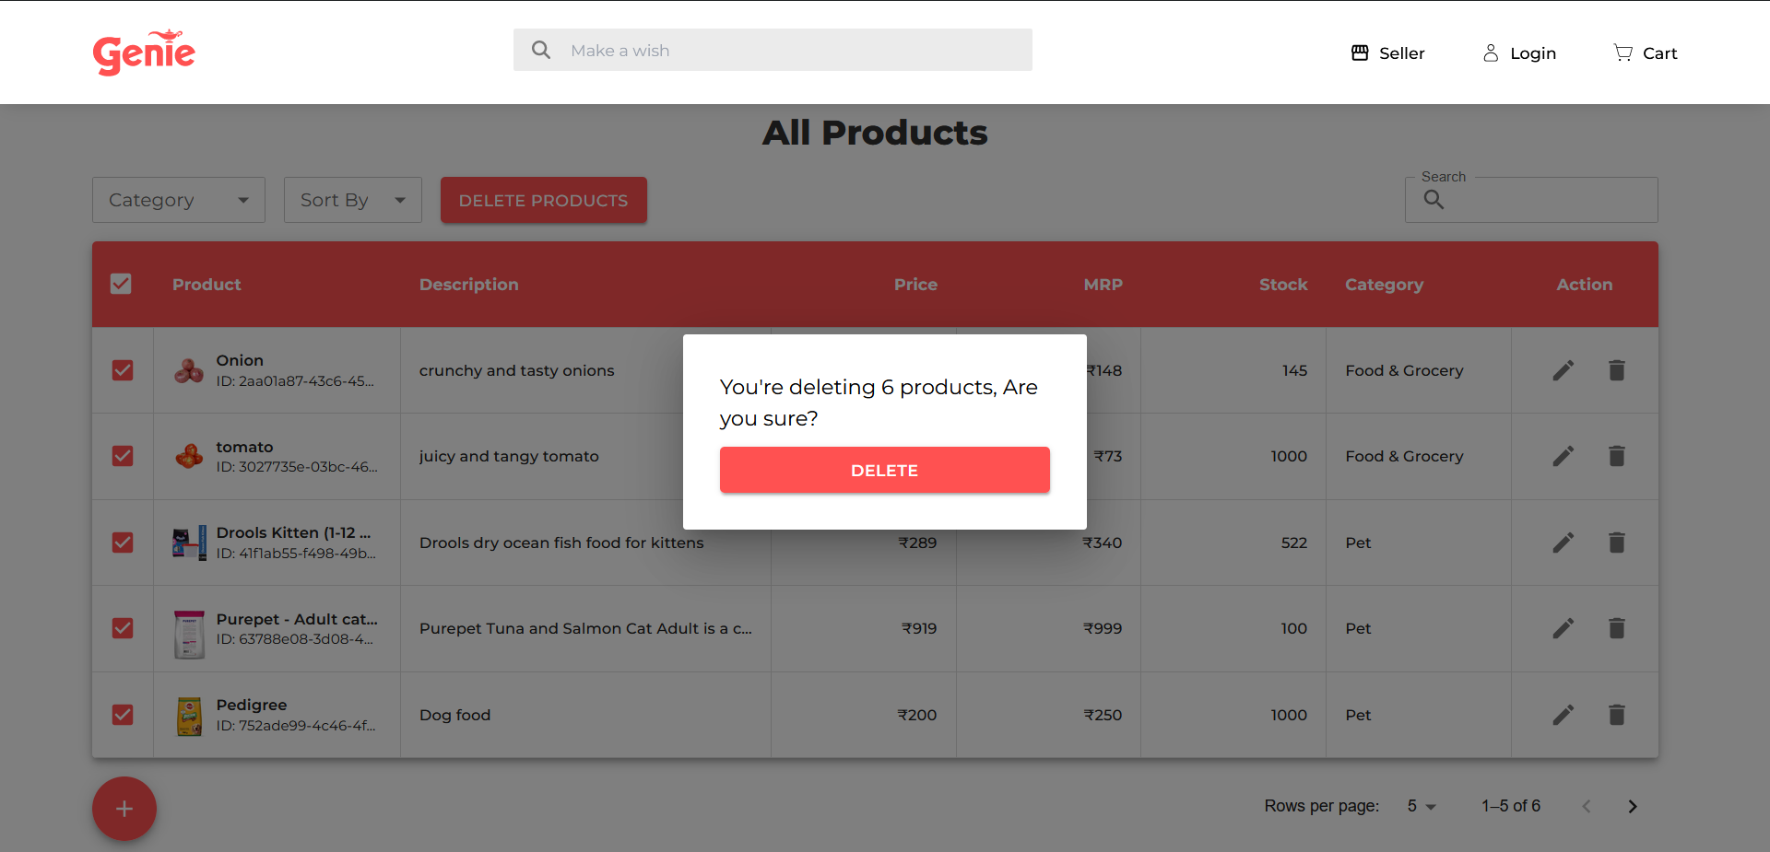

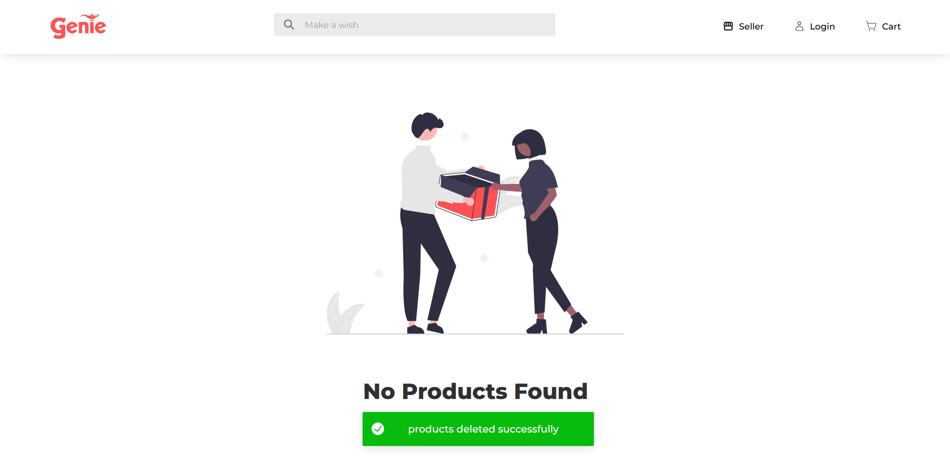

**Restoration of Deleted Products**

Seller can view the deleted products and restore it if they want

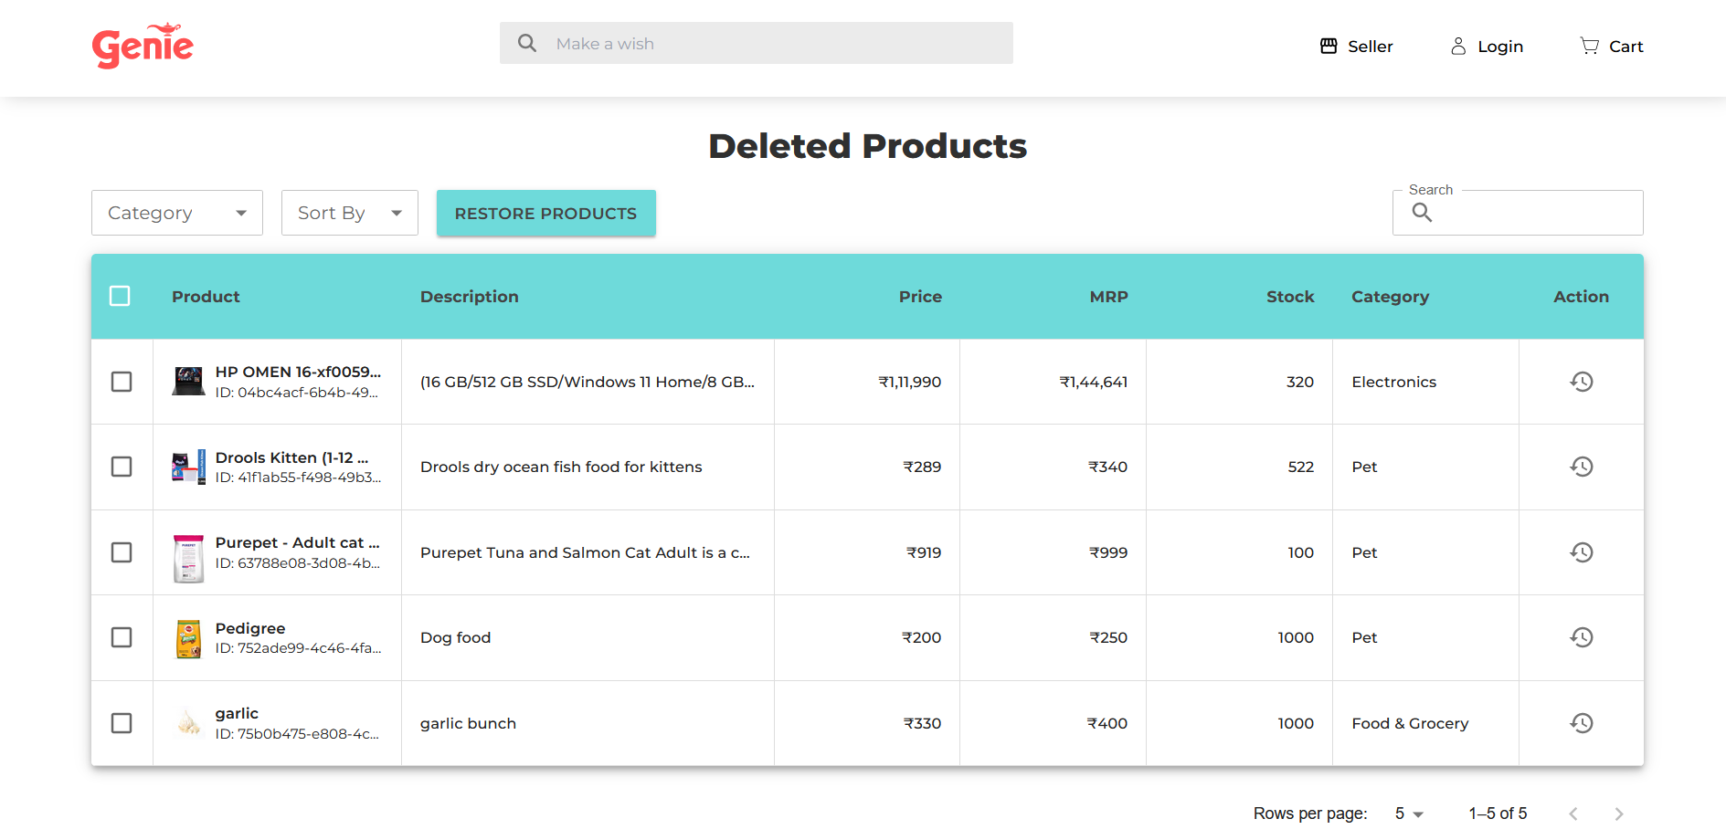Restoring Products

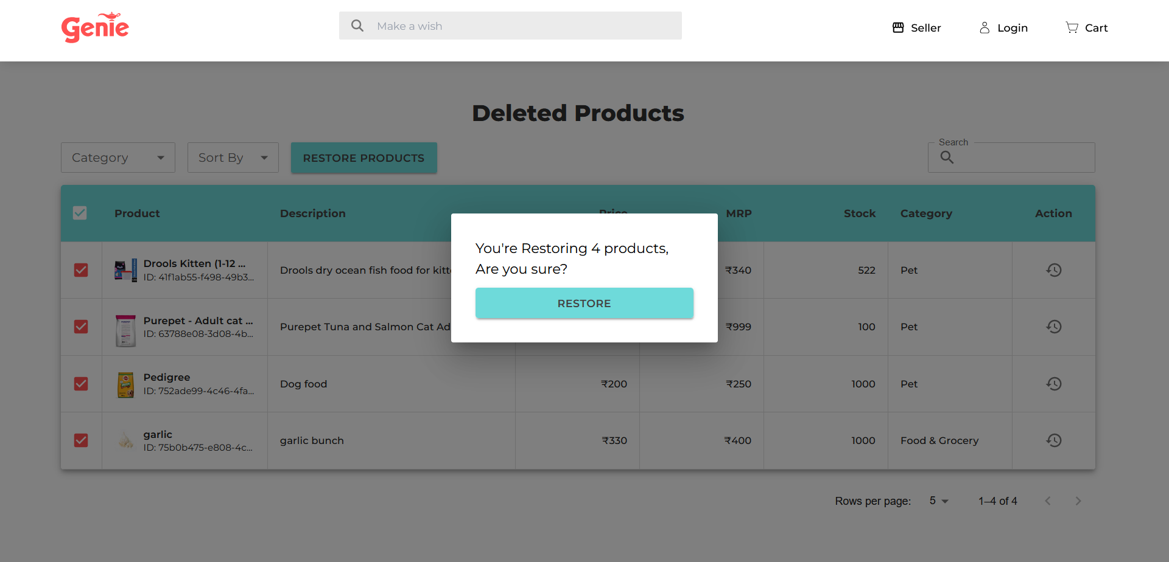

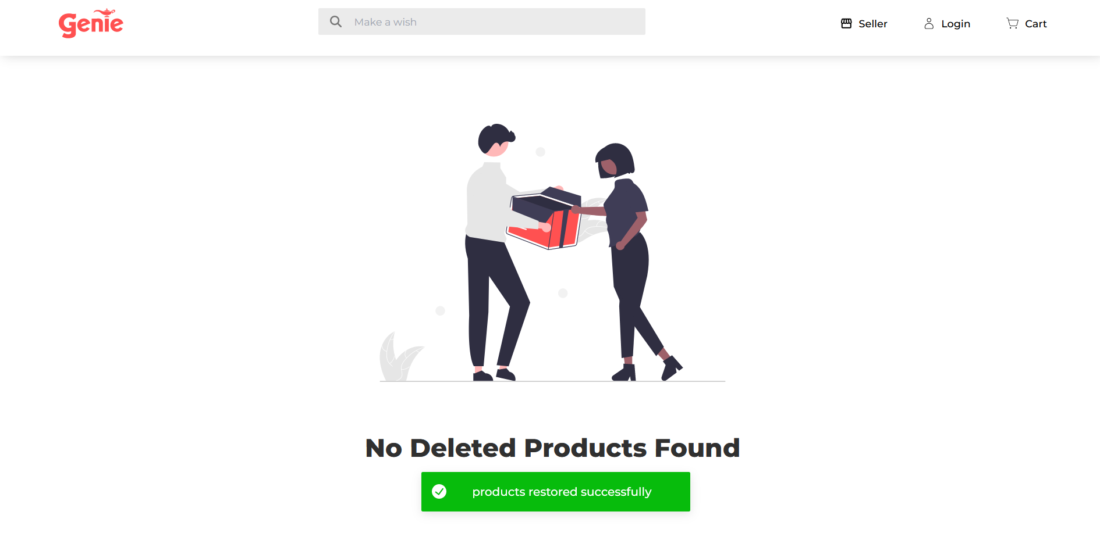

**Admin Module**

Manage admins page

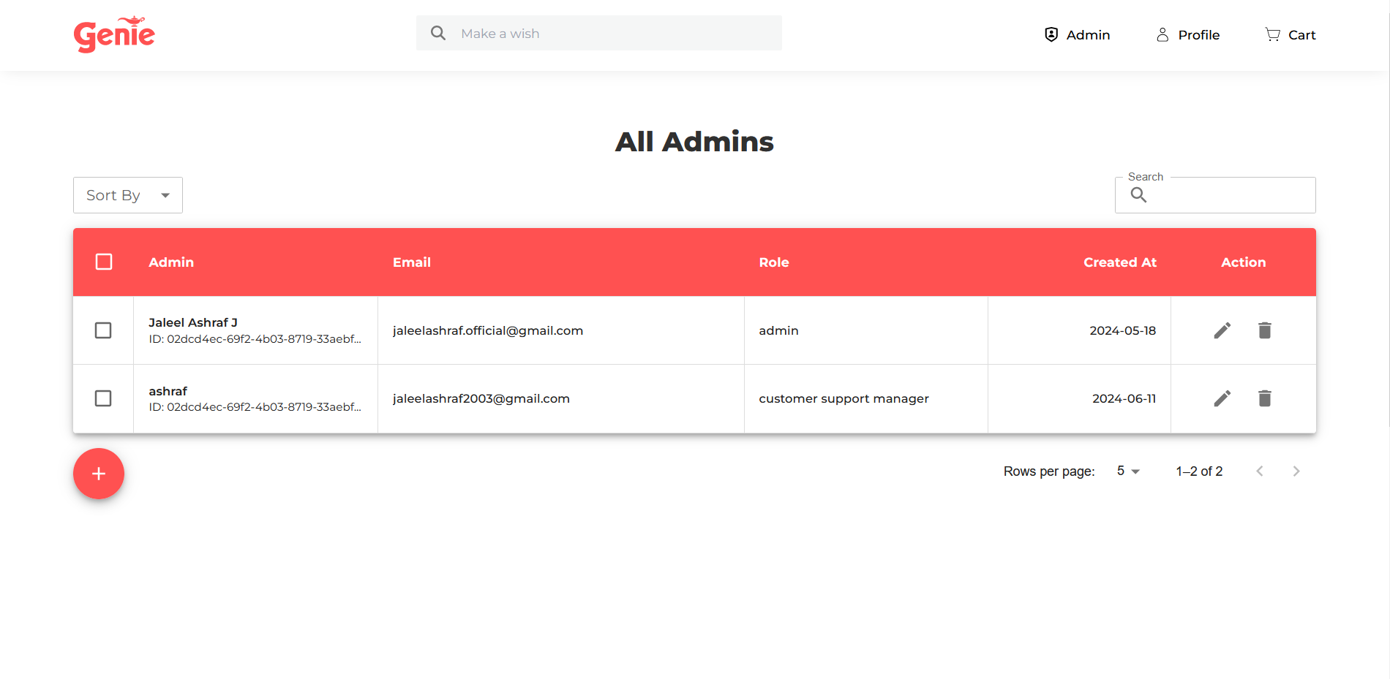

Add new admin page

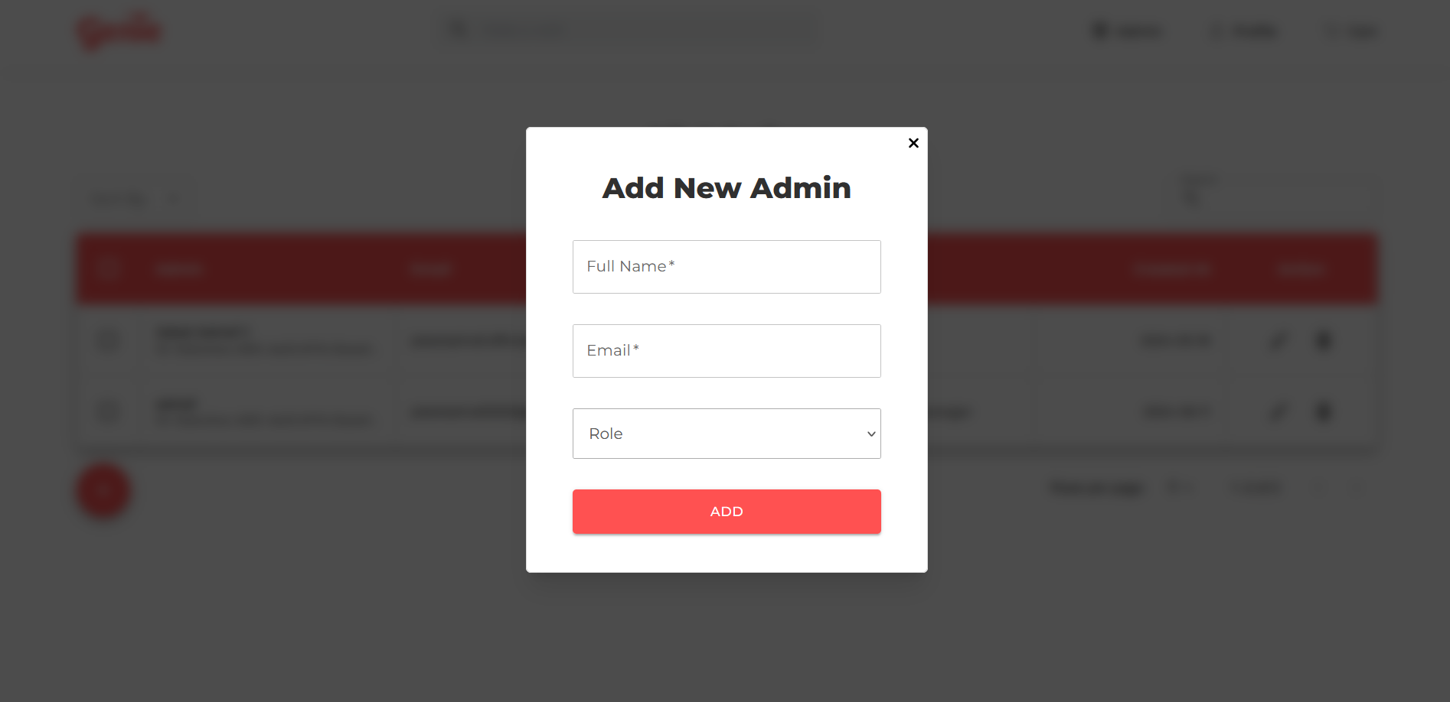

Change admin role page

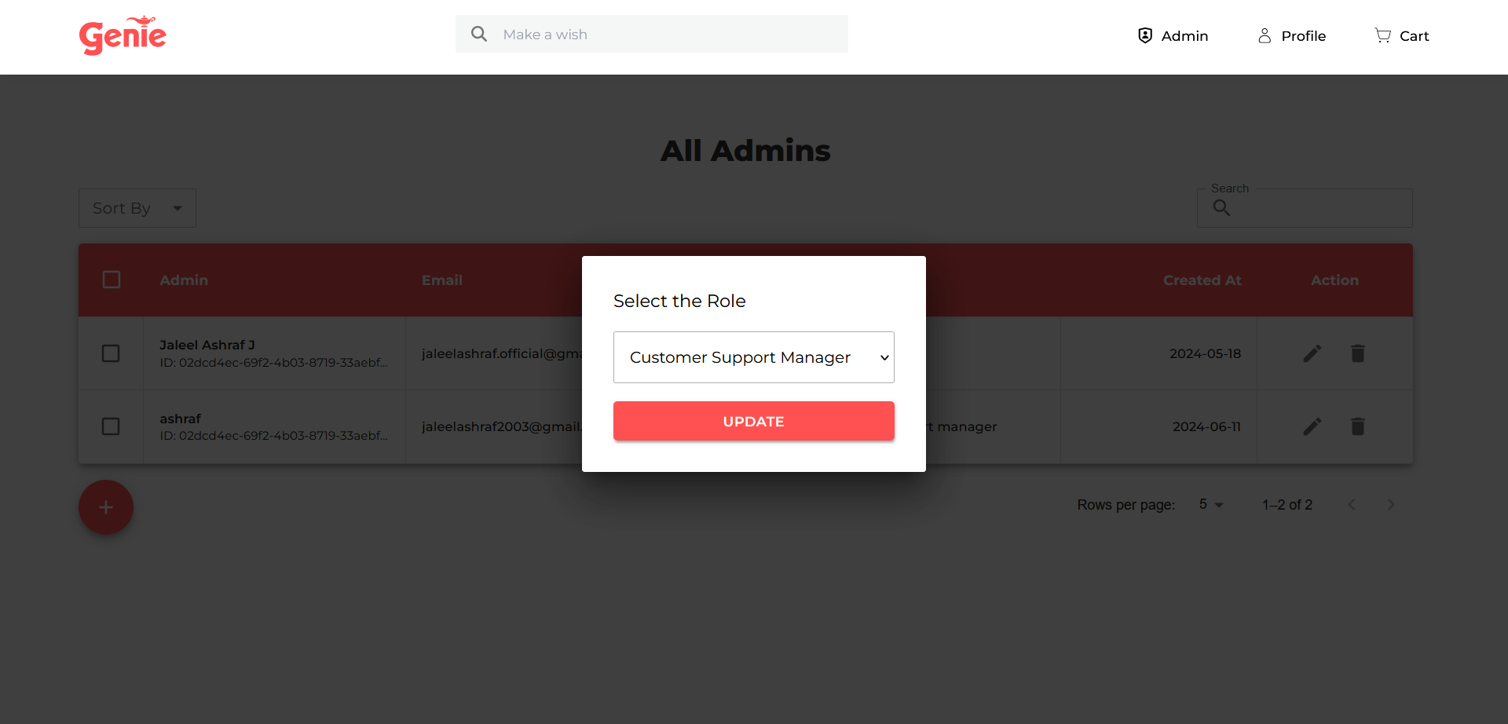

1.3. Delete admin confirmation

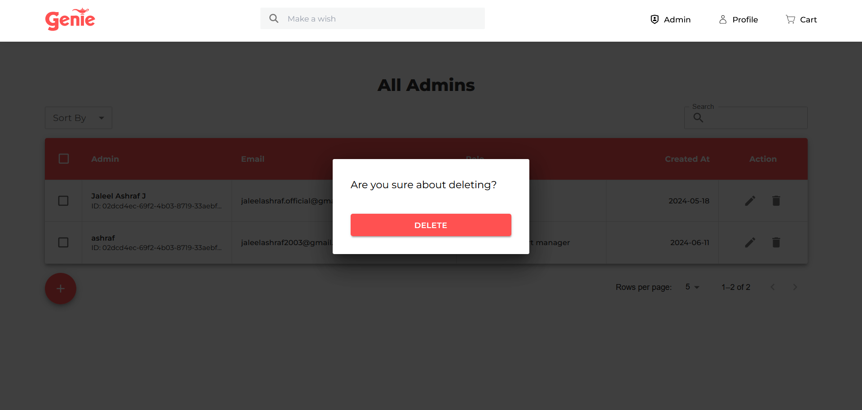

1.4. Sorting options

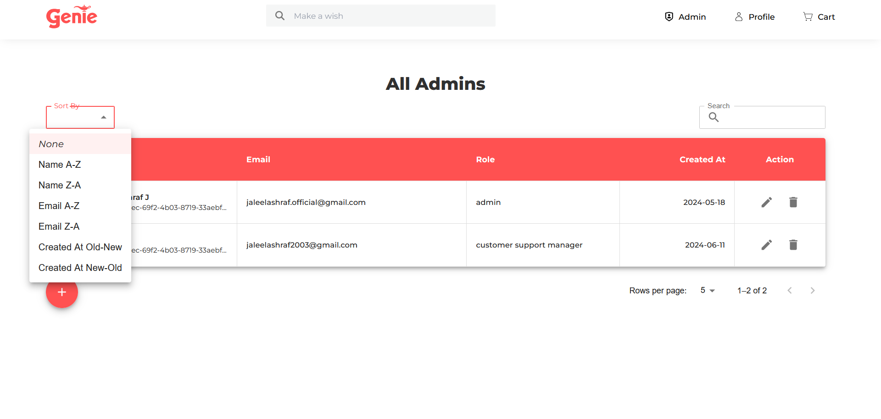

**Manage users page**

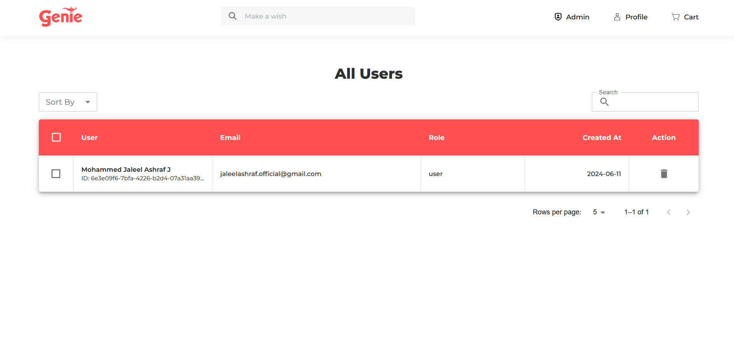**3. Manage sellers page**

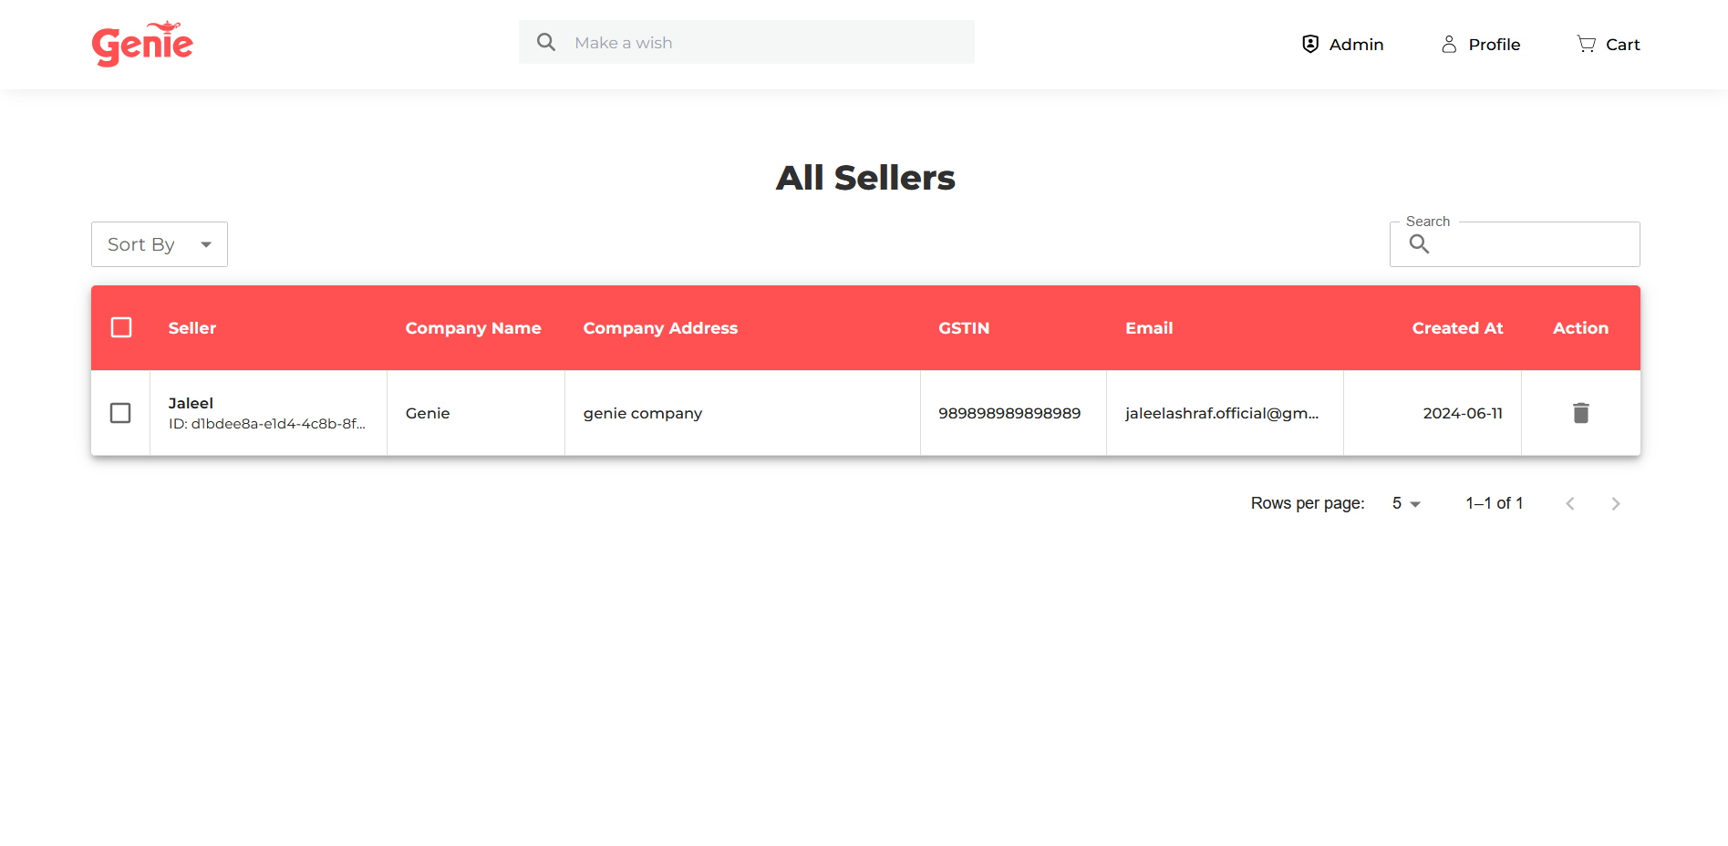

**Manage seller applications page**

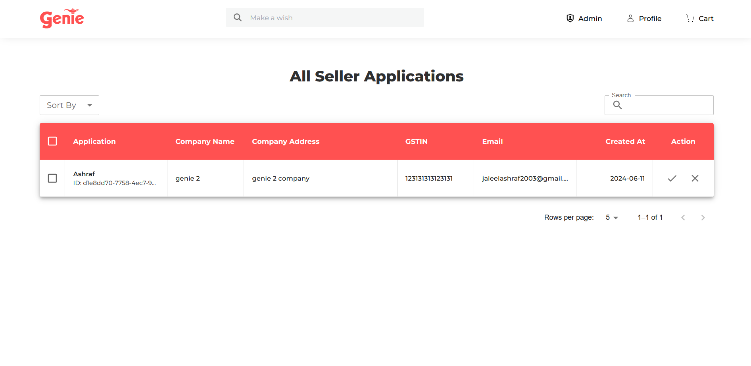

**Approve seller application**

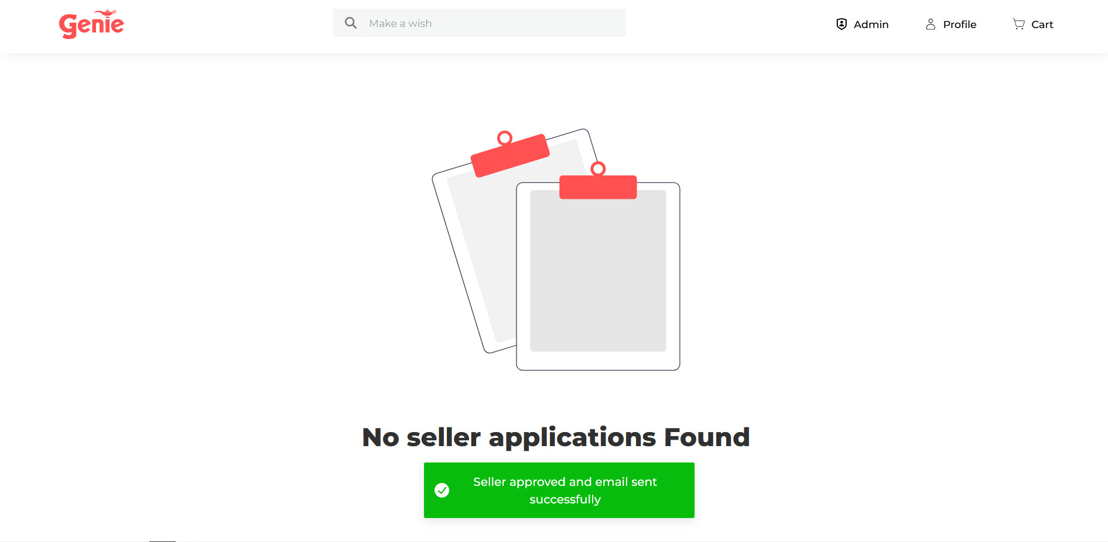

**Reject seller application**

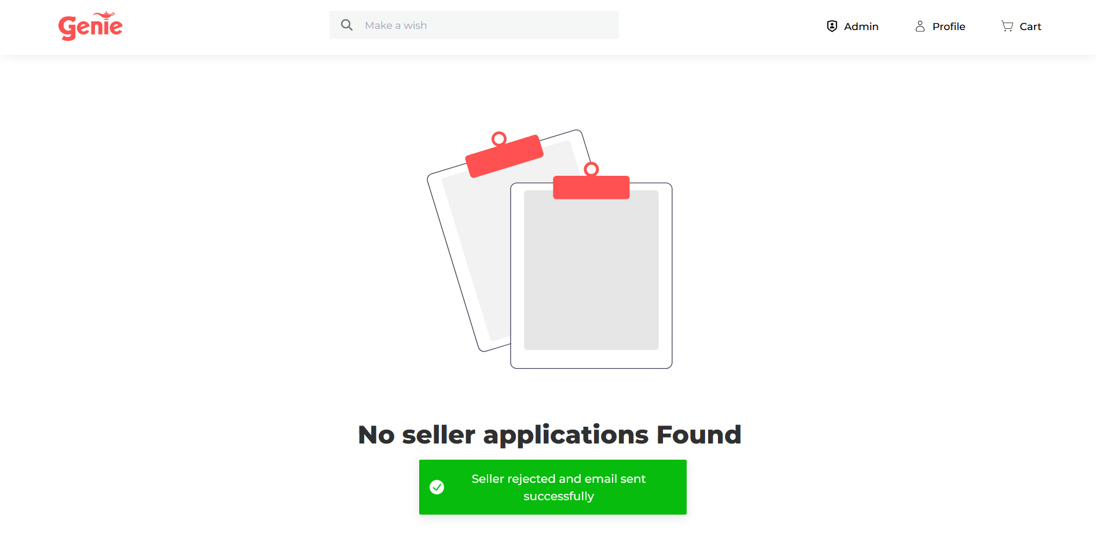

**Seller Dashboard**

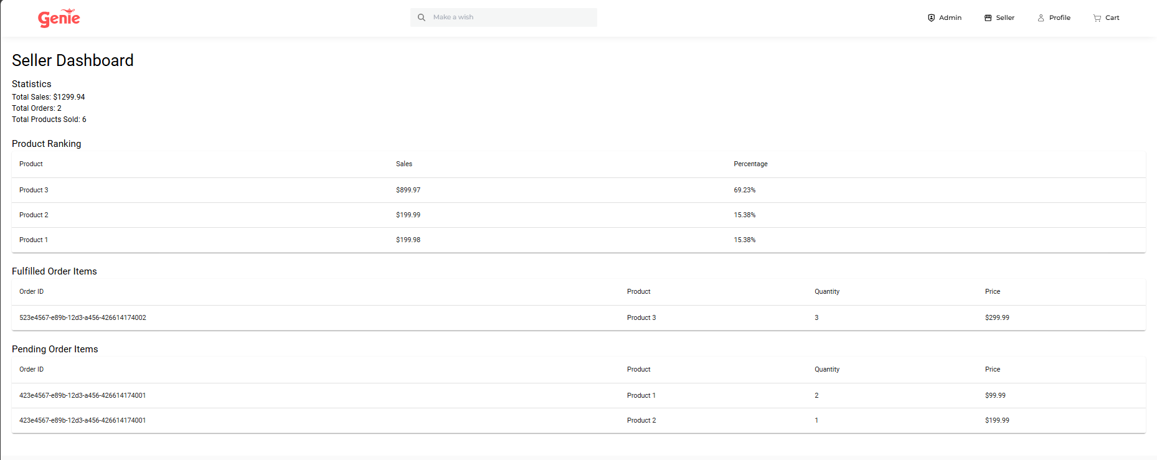

**Checkout page**

Add delivery page if no address found

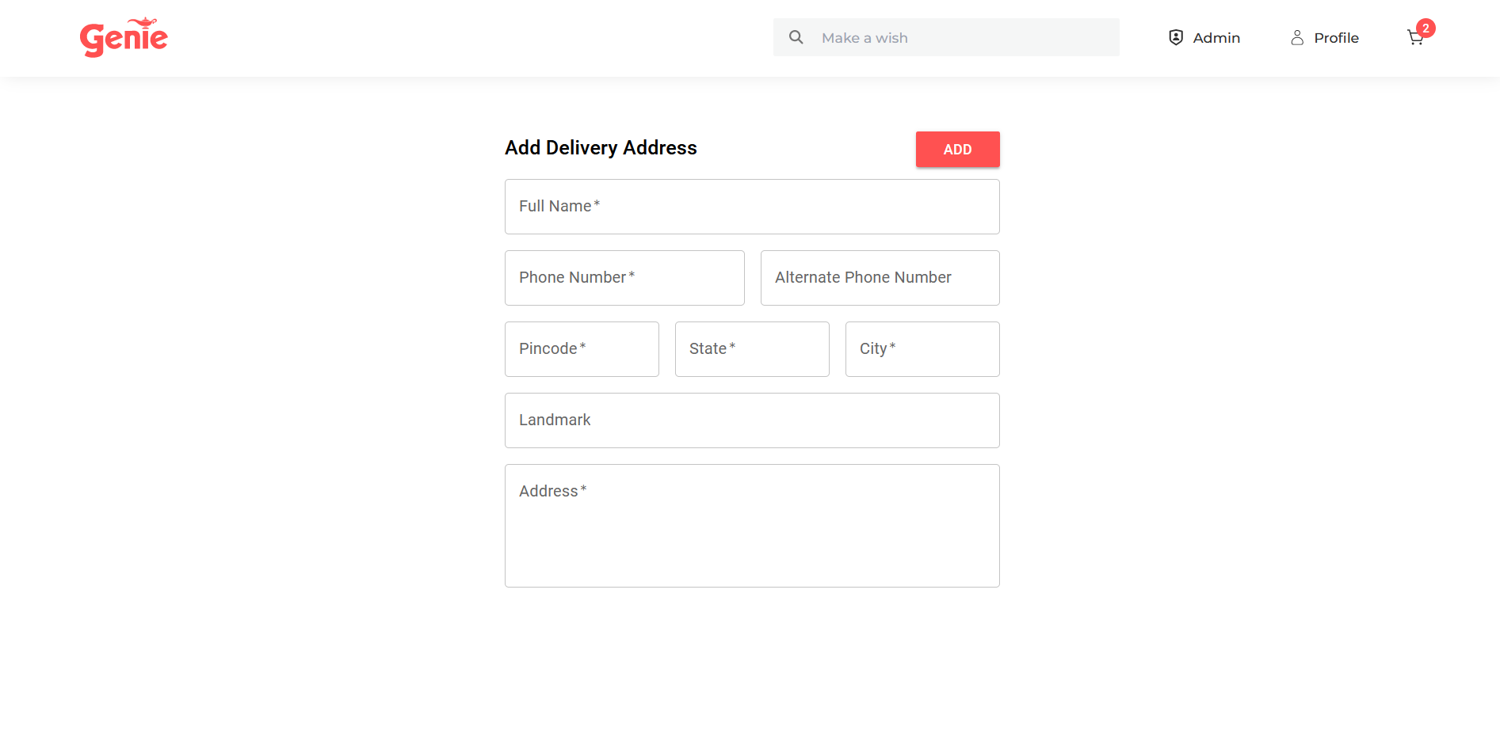

Select delivery address

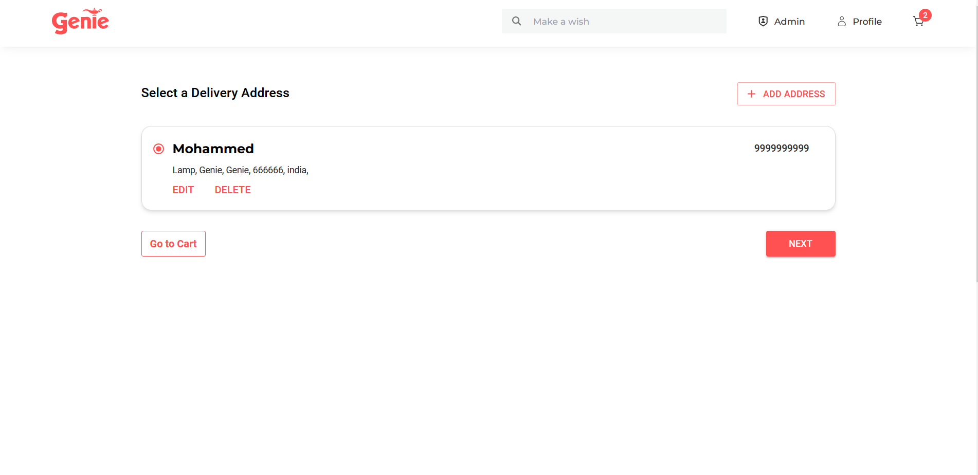

Order summary and payment page

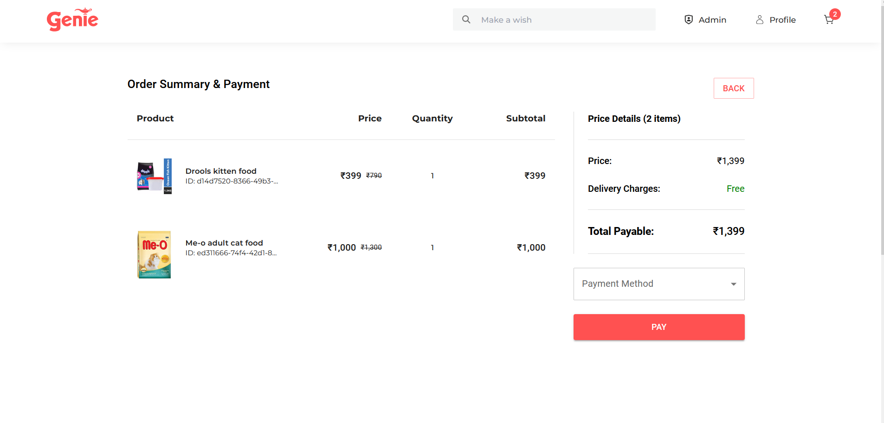

UPI payment

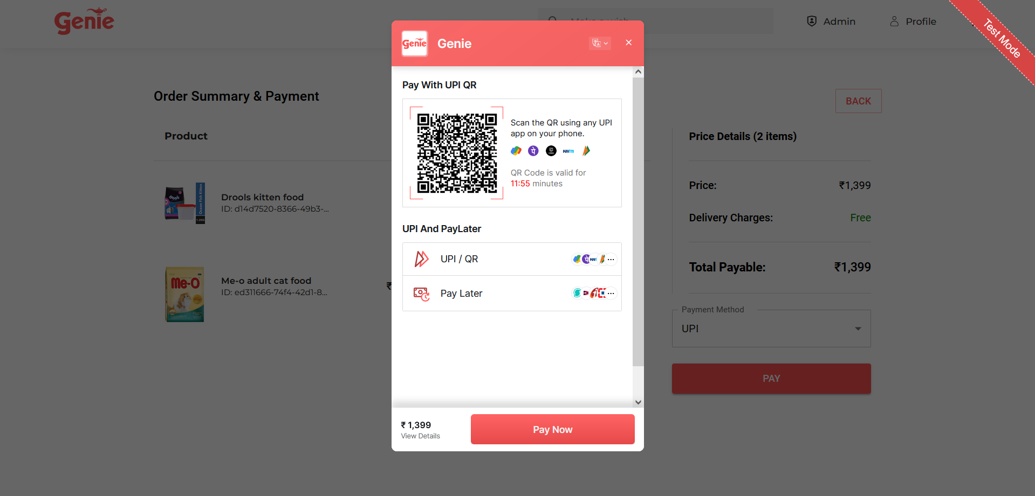

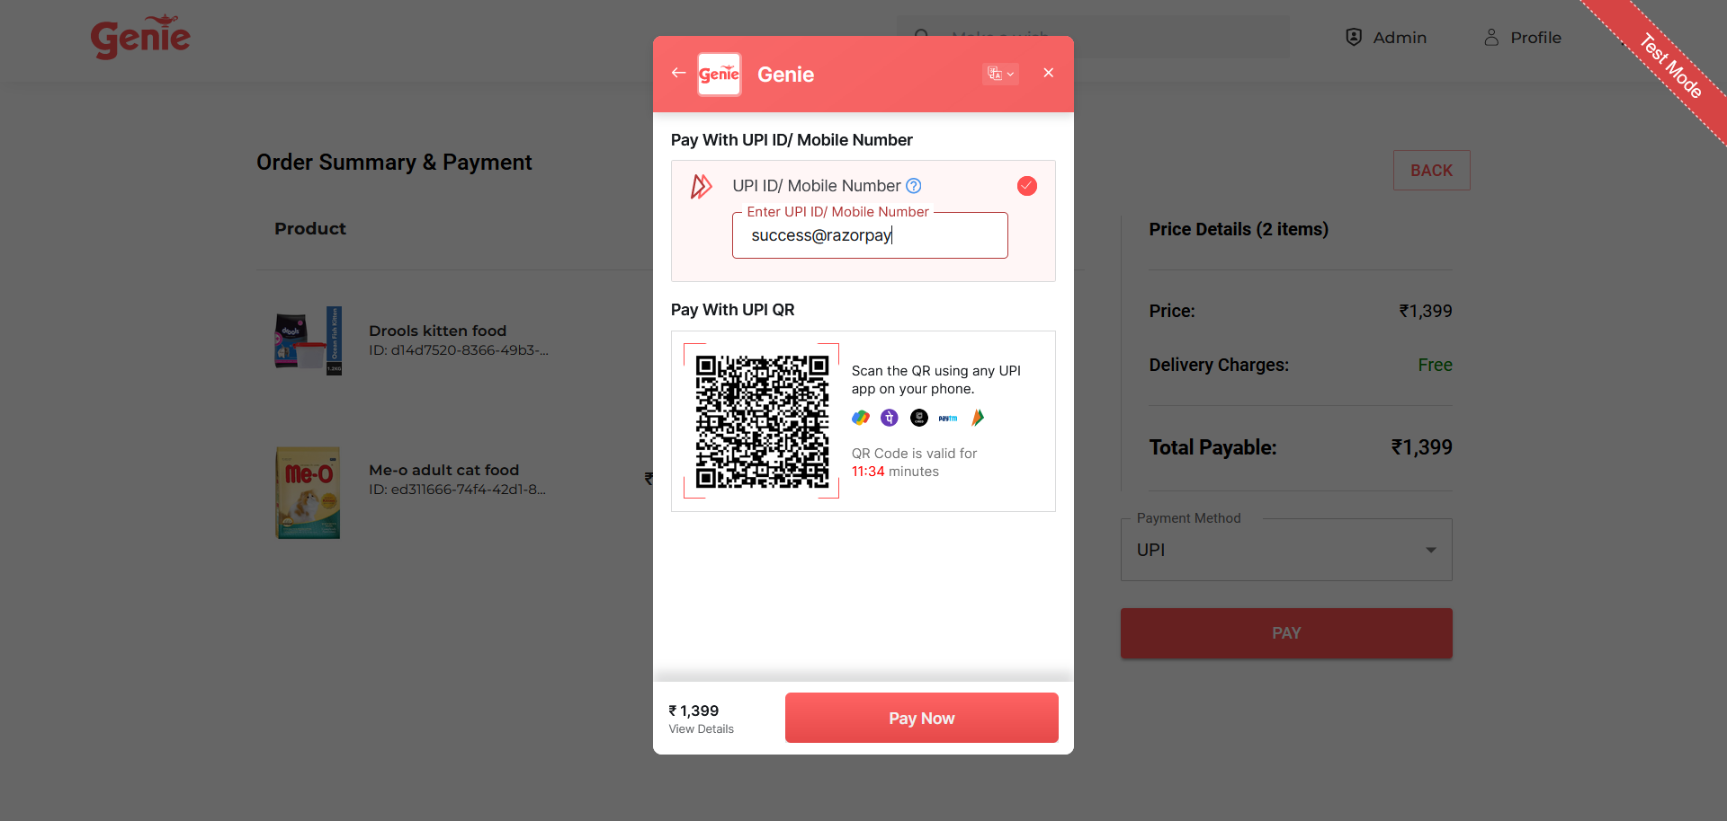

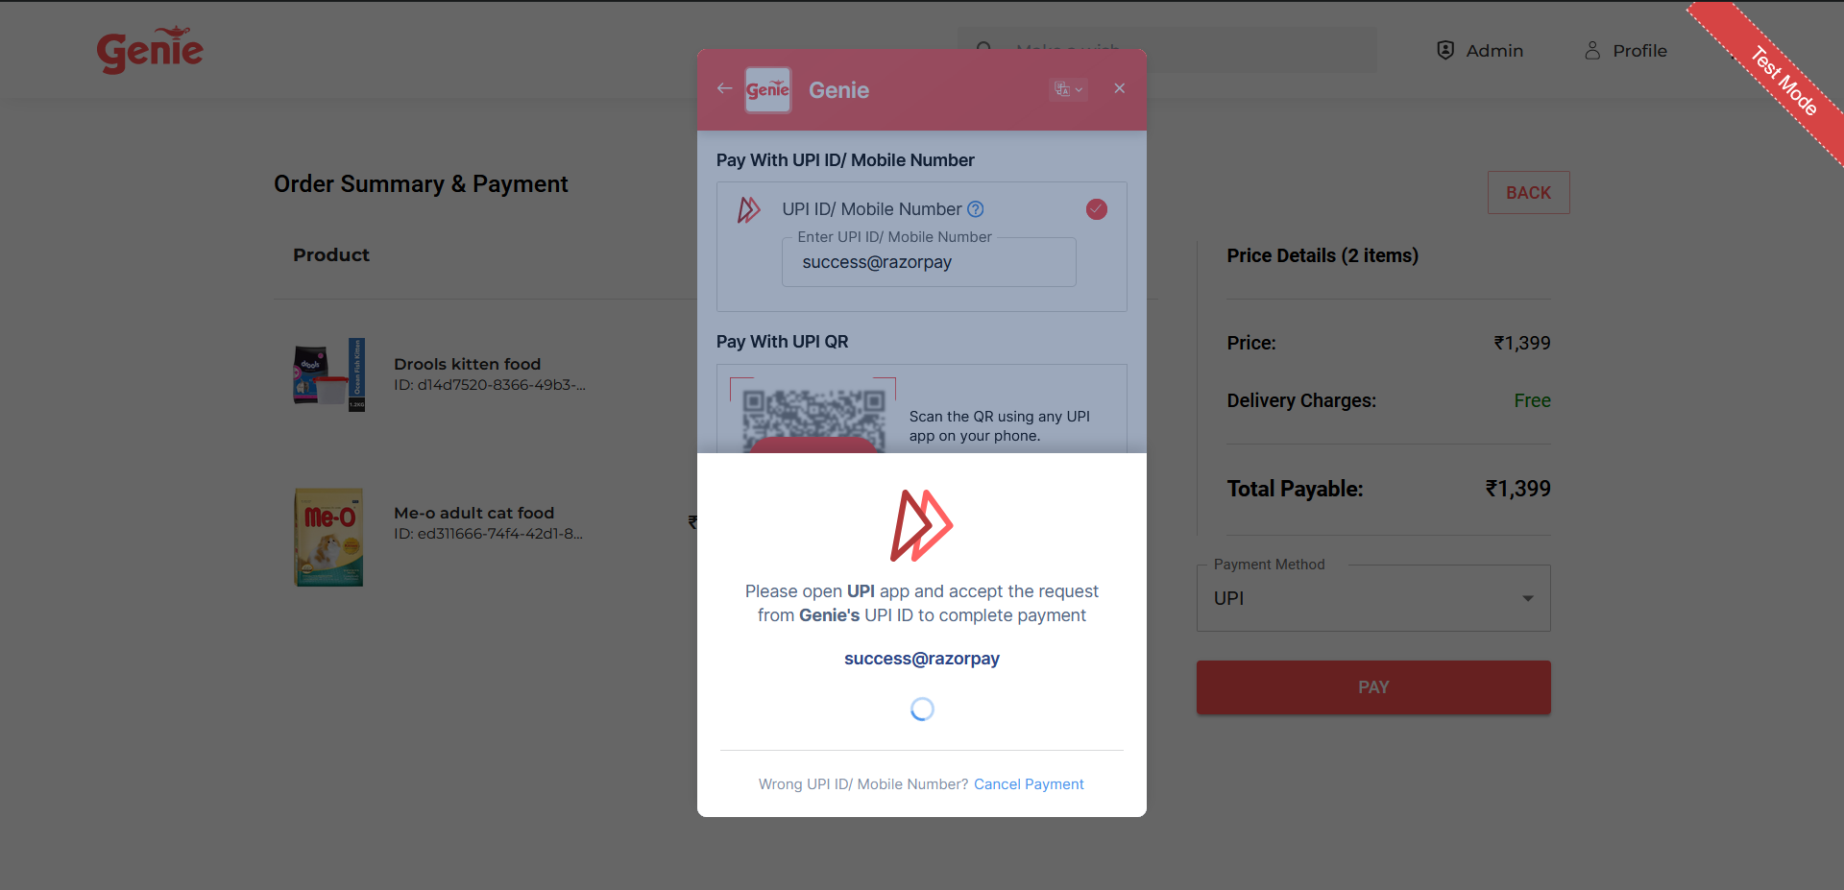

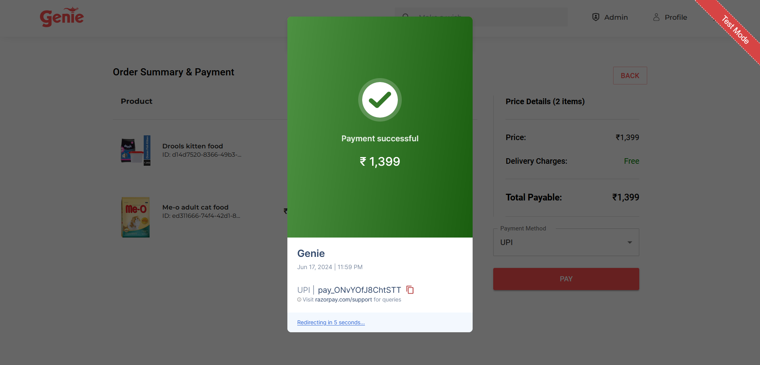

Successful payment and order placement

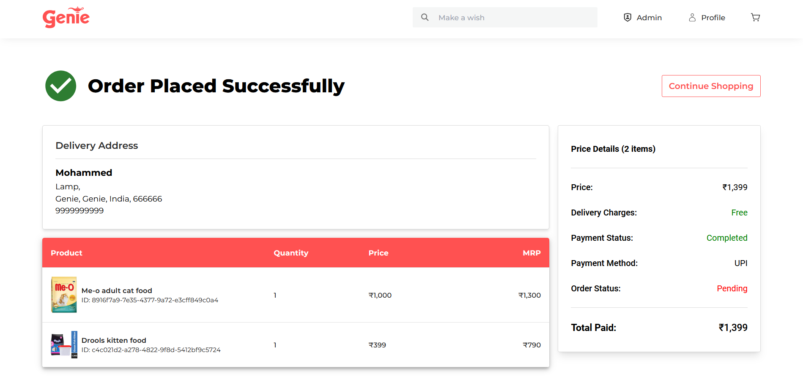

User orders page

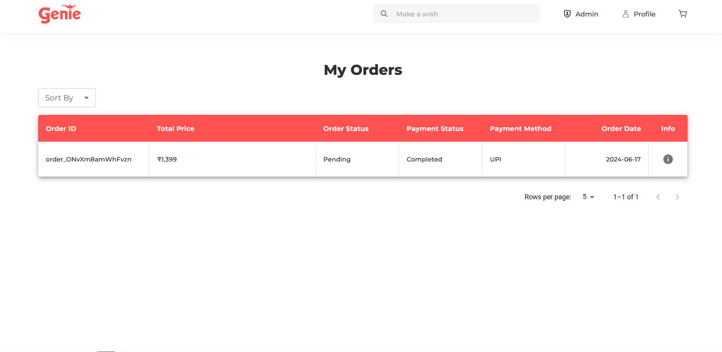

Order details

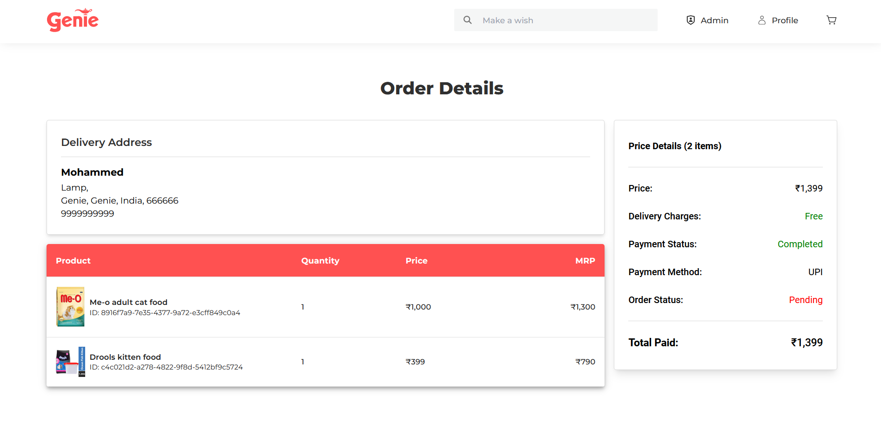

Admin Dashboard

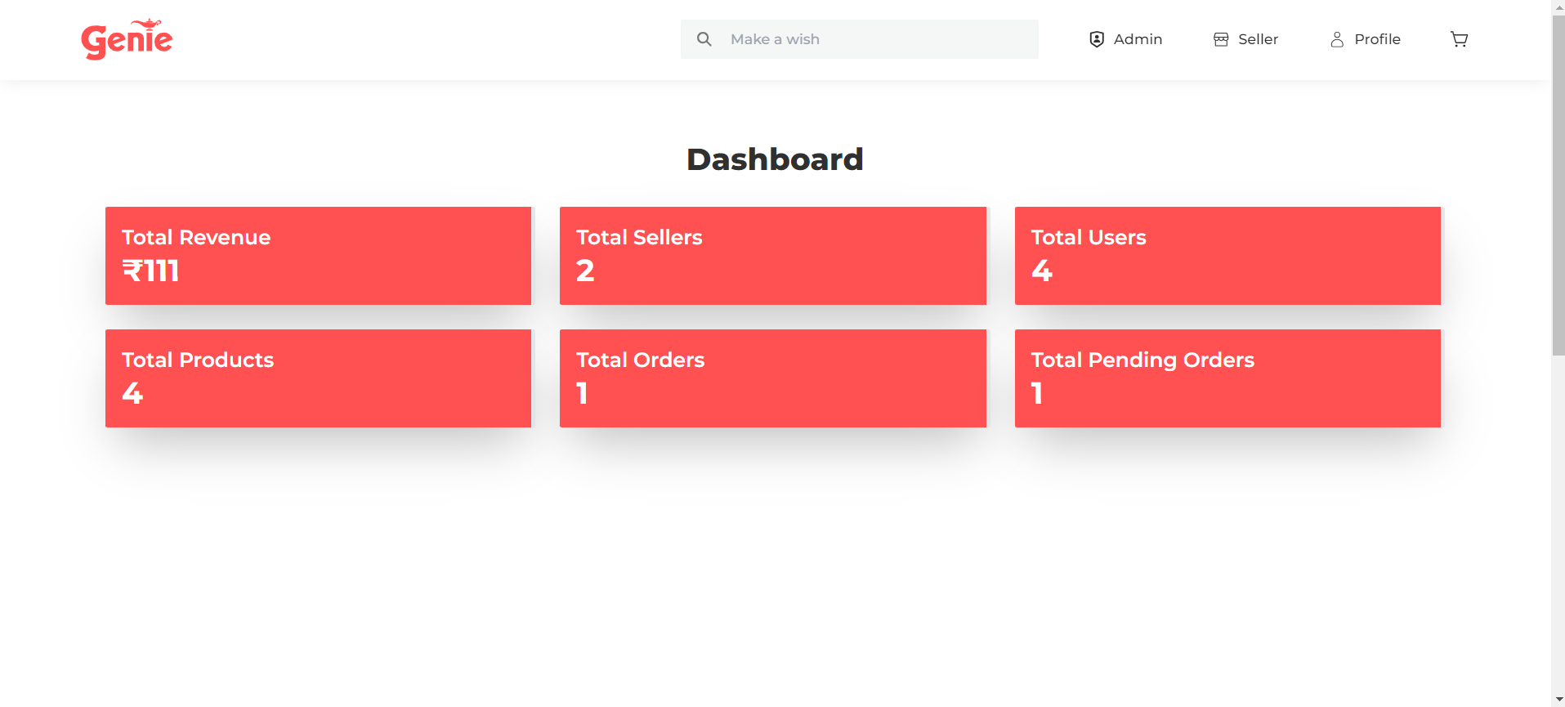

USER account page

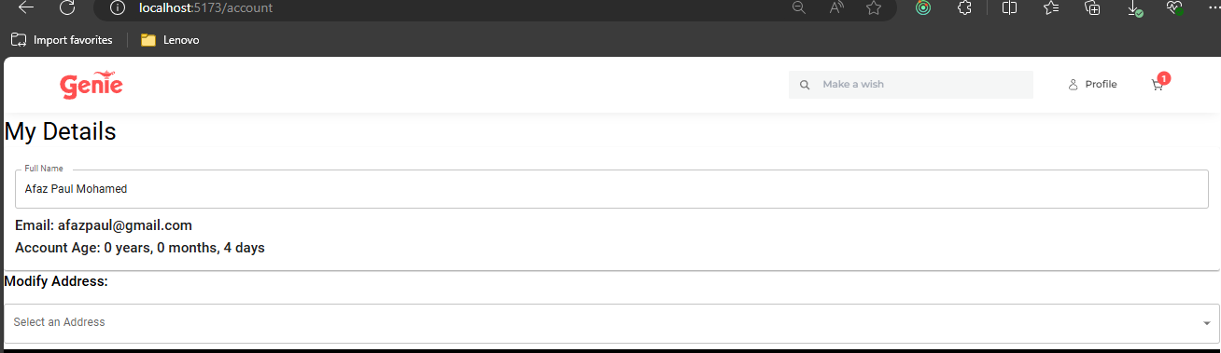



**CONCLUSION**

The e-commerce website internship was a rewarding experience, marked by successful collaboration, efficient time management, and knowledge sharing. Using modern technologies like React, Node.js, MySQL, and Razorpay, the project delivered a scalable, secure, and user-friendly platform that streamlined operations and enhanced user experience.

Teamwork and clear communication ensured seamless integration of all components, while structured planning and prioritization helped meet deadlines. Regular knowledge-sharing sessions fostered a collaborative learning environment.

The project achieved its objectives, addressing industry challenges like inefficiencies and scalability issues, while enhancing my technical expertise, teamwork skills, and real-world development experience.

.

**REFERENCES**

[reactcommunity](https://react.dev/community)

[tailwindcss](https://tailwindcss.com/)

[material-ui](https://mui.com/material-ui/)

[redux.js](https://redux.js.org/)

[nodejs](https://nodejs.org/en/about/get-involved)

[mysql](https://dev.mysql.com/)

[expressjs](https://expressjs.com/en/resources/community.html)

[cloudinary](https://community.cloudinary.com/)

[razorpay](https://dev.to/t/razorpay)